Personal pronouns: subject/object (Unit 2)
Worksheet
6B6
Name No.: ______ Class: ________ Date: _____/ _____/ _____

A. Find the missing object pronouns in the word cloud and write them on the table.
Subject | I | you | he | she
Object | me | ¹  __________ | ²  __________ | her
Subject | it | we | you | they
Object | it | ³  __________ | ⁴  __________ | ⁵  __________

B. Circle the correct option to complete the sentences.
1. This is Gary’s mobile. Can you give it to you / him?
2. Tom sets the table every day. He / Him is very helpful.
3. My dogs are great. I really like it / them.
4. We cut the grass on Saturday. Do you want to help we / us?
C. Fill in the blanks with the correct personal pronoun subject or object from the box.
her
you
him
they
he
1. My father washes the dishes. __________________ also cooks meals.
2. Amy lives in my street. I see __________________ every day after school.
3. Are Amy and you at the park? I can meet __________________ there.
4. Matilde and Robert live next door. __________________ are very friendly neighbours.
5. That’s my favourite actor! Do you know __________________?

D. Complete the text with the correct personal pronouns (subject or object).
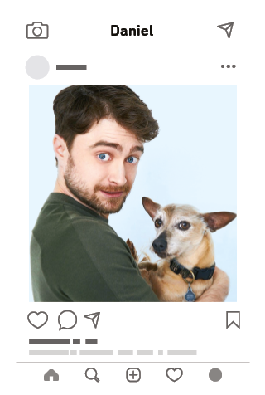
What a boring Saturday! I’m so bored! My mother says it’s cleaning
day, so my sisters and I help ¹ him / her with the chores. ² I / We
are against this idea, but we have to accept ³ you / it! There’s no
other option! My brother Tom never does anything. ⁴ They / He
says he has to study! Good excuse! My sisters Paula and Beth dust
the furniture and I sometimes help ⁵ they / them! Our Dad also
washes the car on Saturdays and my sister Lydia always helps
⁶ he / him! It’s a boring family cleaning day… well, not for everyone
because my brother doesn’t do it with ⁷ us / we! How lucky!
The only thing that cheered me up?? A photo of Daniel Radcliffe
with his dog ! Check it out! Aren’t ⁸ he / they funny?

