Prepositions of place (Unit 2)
Worksheet
7A6
Name No.: ______ Class: ________ Date: _____/ _____/ _____
A. Look at the picture. Who is speaking? More than one answer is possible. Write the letters a-e.

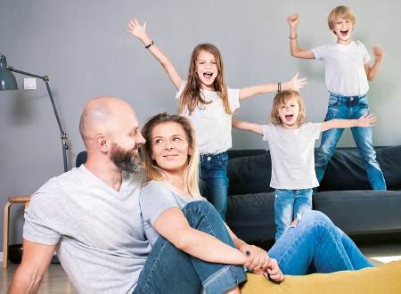
1. “I’m sitting on the floor.”
c) John


2. “I’m on the sofa.”
b) Nancy

3. “I’m between Nancy and John.”


4. “There are two cushions behind me.”
d) Patty

5. “I’m behind Tessa.”



6. “I’m in front of Thomas.”
e) Tessa
a) Thomas

7. “I’m next to Patty.”

8. “John is behind me.”

B. Look at this picture. Fill in the gaps with the prepositions of place from the box.
on (x4) | next to | between | in | opposite | above | under

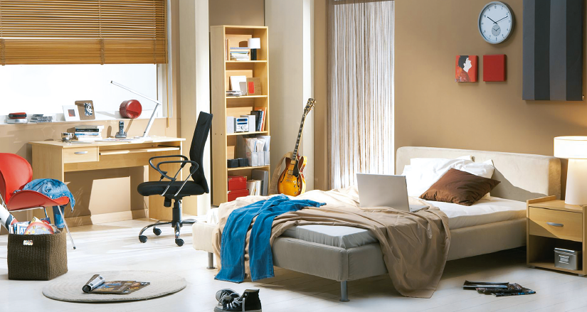
1. The clock is ____________ the wall. | 6. The clock is ____________ the pictures.
2. The trainers are ____________ the floor. | 7. The rug is ____________ the magazines.
3. The books are ____________ the bookcase. | 8. The bookcase is ____________ the bed.
4. The pillows are ____________ the bed. | 9. The jacket is ____________ the red chair.
5. The bedside table is ____________ the bed. | 10. The black chair is ____________ the desk  and the bed.
C. Make two different sentences about the picture from exercise B using prepositions of place.
1.
2.

