Prepositions of place (Unit 2)
Worksheet
7B6
Name No.: ______ Class: ________ Date: _____/ _____/ _____
A. Look at the picture. Who is speaking? Write the letters a-e. First check the meaning of the coloured prepositions of place.





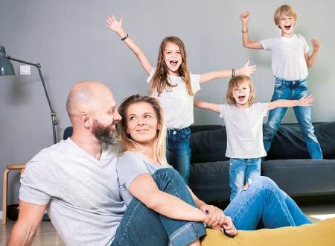
1. “I’m sitting on the floor.”
b) Nancy
c) John
d) Patty
e) Tessa
a) Thomas

2. “I’m on the sofa.”

3. “I’m between Nancy and John.”

4. “There are two cushions behind me.”

5. “I’m behind Tessa.”

6. “I’m in front of Thomas.”

7. “I’m next to Patty.”

8. “John is behind me.”


B. Look at this picture. Circle the correct preposition of place to complete the sentences.
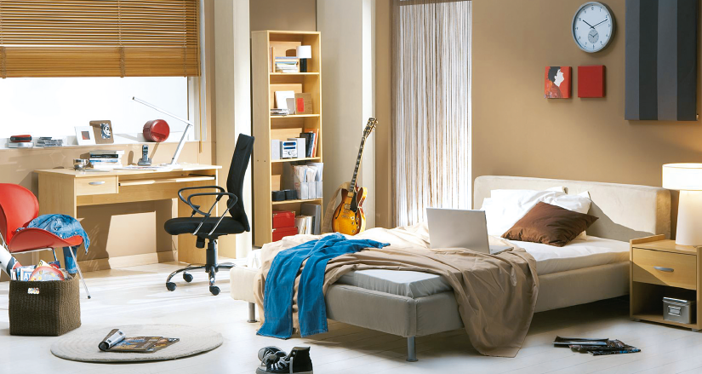
1. The clock is under / on the wall. | 6. The clock is above / on the pictures.
2. The trainers are under / on the floor. | 7. The rug is on / under the magazines.
3. The books are in / above the bookcase. | 8. The bookcase is opposite / in the bed.
4. The pillows are on / under the bed. | 9. The jacket is on / below the red chair.
5. The bedside table is next to / in the bed. | 10. The black chair is in / between the desk  and the bed.

