Word formation (Unit 2)
Worksheet
8A6
Name No.: ______ Class: ________ Date: _____/ _____/ _____
A. Match the puzzle pieces to make nouns. Write the words below.

bookcase
book
case
dish
micro
down
wave
washer
board
stairs
cup
•
B. Complete the words with the correct prefix or suffix from the boxes. Use each one only once.
prefixes: in-; un-; dis-; im-
suffixes: -er; -ful; -less; -ly
1. __________usual | 3. final__________ | 5. __________possible | 7. help__________
2. care__________ | 4. __________honest | 6. cook__________ | 8. __________complete
C. Use some words from exercises A and B to complete the sentences and label the pictures.
The first letter of the words is given.
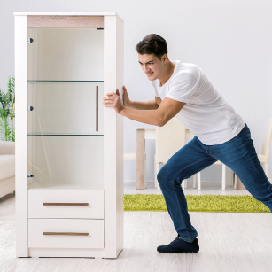  1 | 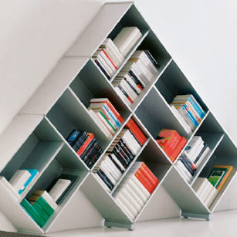  2 | 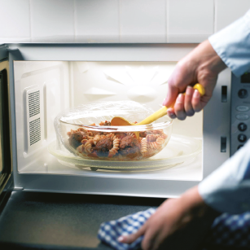  3
1. The 1__________________ is very heavy, but it’s 2__________________ 3__________________
on the ground floor!
d
f
c
b
u
2. What an 4__________________ 5__________________ !
c
m
3. Be 6__________________ with the food in the 7__________________ ! It can be hot!

