Word formation (Unit 2)
Worksheet
8B6
Name No.: ______ Class: ________ Date: _____/ _____/ _____
A. Match the puzzle pieces to make nouns. Write the words below.

bookcase
book
case
dish
micro
down
wave
washer
board
stairs
cup
•

B. Circle the correct option to make new words.
1. usual – unusual / inusual | 5. possible – impossible / unpossible
2. care – careful / uncare | 6. cook – cookly / cooker
3. final – finalful / finally | 7. help – helpless / helply
4. honest – unhonest / dishonest | 8. complete – imcomplete / incomplete
C. Choose words from the box to complete the sentences and label the pictures.
bookcase | microwave | unusual | downstairs | cupboard | finally | careful

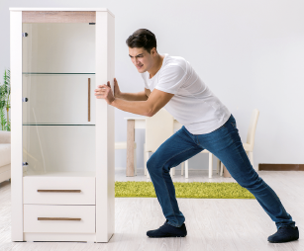  1 | 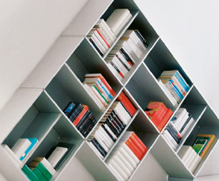  2 | 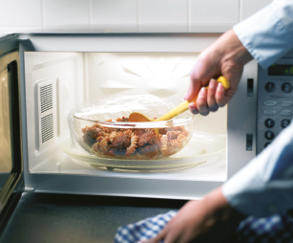  3
1. The 1__________________ is very heavy, but it’s 2__________________ 3__________________
on the ground floor!
2. What an 4__________________ 5__________________ !
3. Be 6__________________ with the food in the 7__________________ ! It can be hot!

