Unit 1
Reading Worksheet
1A6
Name No.: ______ Class: ________ Date: _____/ _____/ _____
Read the magazine article.
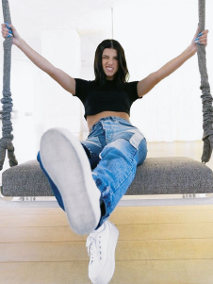

 | Charli D’Amelio  The Face of TikTok | 25  30  35  40 | until 4.30 p.m. and after classes she checks  her agenda (she goes to many TV shows and  gives a lot of interviews) and she practises her  dance routines. She always has dinner with  her family at around 8.30 p.m. and she usually  goes to bed at 11 p.m.  There are two reasons why her fans love  her so much: she shares very creative videos  on TikTok every day and Charli also uses her  influence to raise money for many charity  organisations. As Charli says: “Making dance  videos is my passion. I do what I really like and  at the same time I make a difference!”  The truth is Charli D’Amelio is a popularity  phenomenon… Many teens talk about her and  want to wear a T-shirt with a photo of her on it  or have a pencil case with her name!
5  10  15  20 | Charli Grace D’Amelio was born on 1st May  2004, in Connecticut, USA.  Her father is a politician and her mother  is a photographer. She has got an older sister,  Dixie.  Charli is a student at King School, but she  is also a dancer. She is the first TikTok star to  reach 50 million followers and she currently  has more than 90 million followers.  She is one of the main internet influencers  and many girls want to look like her: she is tall  and slim and she has got long straight dark hair.  Her smile is so beautiful. She is very stylish!  In a vlog about her daily routine, she says her  day is “crazy”. She wakes up at 8 a.m., but she  stays in bed until about 9 a.m. The first thing  she does is to check her mobile phone. Then  she goes straight to the bathroom, brushes  her teeth and takes care of make-up. She gets  dressed, has a milkshake for breakfast and  before going to school she still takes her dogs  for a walk. Her morning classes only start at  10.30 a.m., so she has time! She has classes | 25  30  35  40

A. Complete with Charli’s personal information.

Name: ¹ Surname: ²
Date of birth: ³ Nationality: ⁴
Occupations: ⁵ and ⁶
Father’s job: ⁷
Mother’s job: ⁸
Number of siblings: ⁹

B. Order the activities Charli does in the morning before going to school. Write 1-5.

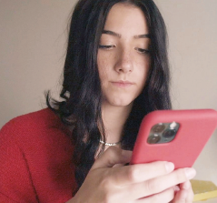
Charli
and her sister
a)

c)

e)

b)

d)

C. Complete the sentences using ONE word, according to the text.
1. Charli’s sister’s name is _______________________.
2. Charli’s hair is long, dark and _______________________.
3. She has got a beautiful _______________________.
4. She checks her agenda after _______________________.
5. She also practises her dance _______________________ after classes.
6. She has dinner with her _______________________.
D. Answer the questions about the text. Give complete answers.
1. How many followers does Charli have on TikTok?

2. What time does Charli get out of bed?

3. Do her classes start early in the morning?

4. How often does she share videos on TikTok?

5. What are the two reasons why her fans love her so much?

