Unit 2
Reading Worksheet
2A6
Name No.: ______ Class: ________ Date: _____/ _____/ _____
Read this text from a website page and look at the pictures.



start | services | products | photos | news | contact
Buckingham Palace
Behind the scenes!
 |  | 5  10 | How many rooms are there in your house? Six, seven… maybe ten? How about 775!  That’s the number of rooms there are in Buckingham Palace, the official London home  of Queen Elizabeth II. These 775 rooms include 19 state rooms, 52 royal and guest  bedrooms for the most important visitors like presidents and kings and queens from  other countries, 92 offices and 78 bathrooms. There is also a gallery, a cinema, a ballroom  and a dining table for 60 people. You can find more than 300 clocks on the walls throughout  the palace.  The garden is huge and it has a swimming pool and a lake. The balcony of the palace  is one of the most famous in the world because this is where the Royal Family stands and  waves to the public when there are important ceremonies or events.  There are 1200 members of staff working for the Queen inside the palace and there are  188 staff bedrooms. Being a royal butler¹ or servant is a demanding², but rewarding³ job.
 |  | 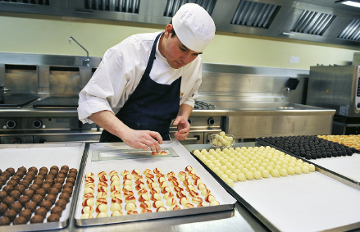  1 |  | 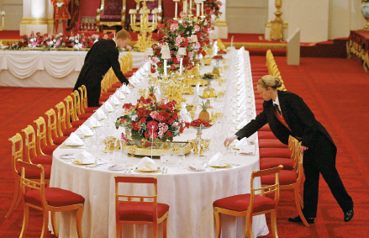  2
 |  | The chefs at the palace are always busy.  This chef is baking chocolates and cookies for more than 150  guests. After that, there’s the washing-up.  It takes 15 people to do the washing-up after a banquet. |  | The Queen invites more than 50,000 people every year to  banquets and parties. They take place in the ballroom.  These servants are setting the table. Everything must be  perfect!
 |  | Vocabulary: ¹ butler = mordomo; ² demanding = exigente; ³ rewarding = recompensador.
A. What do these numbers refer to? Match. Write the letters a-f.
1. nineteen a) People needed to do the washing-up after a banquet

2. fifty-two b) Clocks on the walls

3. one hundred and eighty-eight c) Royal and guest bedrooms

4. sixty d) State rooms

5. fifteen e) Staff bedrooms

6. three hundred f) People that can sit at the dining table

B. Read the sentences and tick (✓) True or False.
TRUE FALSE
1. Buckingham Palace is in London.

2. There are more offices than bathrooms in the palace.

3. There is a room where you can watch films.

4. There is a swimming pool, but there isn’t a lake in the garden.

5. The members of staff don’t sleep in the palace.

C. Answer these questions about the text. Give complete answers.
1. How many rooms does Buckingham Palace have?

2. Why is the balcony of the palace one of the most famous in the world?

3. What is the chef in photo doing?
1

4. Are the servants in photo doing the washing-up?
2

5. Where do the royal banquets and parties take place?

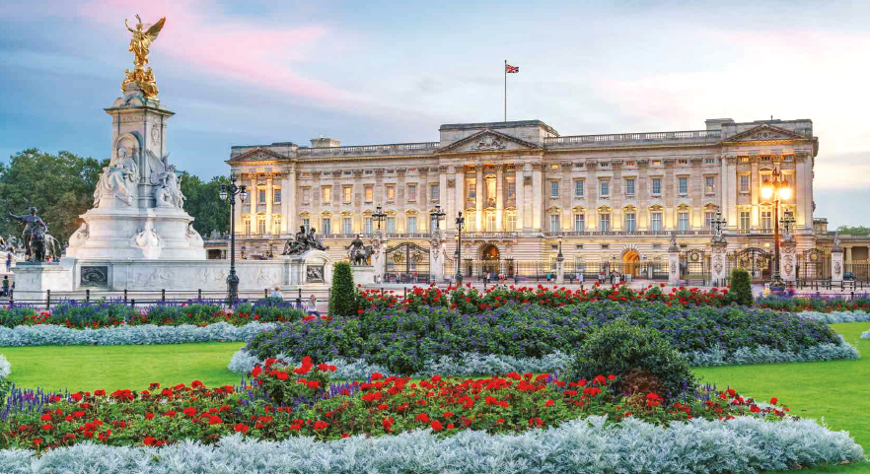
Buckingham
Palace

