Unit 3
Reading Worksheet
3B6
Name No.: ______ Class: ________ Date: _____/ _____/ _____
Read the blog post.


start | services | products | photos | specials | contact
 |  |  | 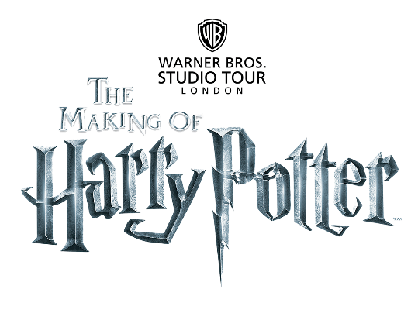
 |  | 5  10  15  20 |   ommon students like me go to common schools like mine: Parkfields Middle  School. It’s in Bedfordshire, 70 km from London. We have all the common subjects,  like English, maths, history… there’s an Arts Club and a Swimming Club and we all  like to study there because the school has good facilities (spacious classrooms,  labs, a fantastic library and a giant gym) and the teachers are great! But… let me tell you  all about our last school trip! Forget about all these “common things” in your school life  and focus on magic, wizards¹ and witchcraft²! That’s it! We went to the Warner Bros. Studio  Tour London to discover everything about the authentic sets used in the making of the  Harry Potter film series and Hogwarts School.  We left school at around 7 a.m. and arrived in historic Oxford one hour later. We walked  around and we felt Harry, Hermione and Ron (famous characters from the films) were  right behind us in some magical parallel universe. When we entered the studio for The  Making of Harry Potter Tour, we walked in the famous Diagon Alley and then we went  inside the Great Hall and explored Dumbledore’s office and then the Gryffindor common  room. What I liked the most? Definitely the Potions Classroom, with over 950 potion jars  on the classroom walls and Professor Umbridge’s office. I liked it because it’s the only  pink office in Hogwarts. Before we left, I went to the souvenir shop and, as a fan of Gryffindor  House, I bought Harry Potter’s magic wand and some magnetic bookmarks. I really wanted  a backpack, but I didn’t have enough money. I had a lot more to tell you about this trip,  but to be honest, this “world of magic” is so fantastic that all I want to do now is to go  to sleep and dream of a school like this!  Jackie, 12, Bedfordshire (London)
 |  | Vocabulary: ¹ wizards = feiticeiros; ² witchcraft = bruxaria.

A. Circle the correct synonym for the words in bold from the text.
1. spacious = huge / magnetic | 4. entered = left / came in
2. discover = forget / find out | 5. honest = sincere / famous
3. authentic = real / fantastic | 6. fantastic = magic / amazing

B. Read the sentences and correct the underlined information. Use words/expressions from the box.
great | Warner Bros. Studio Tour London | history | a common

1. Parkfields Middle School is an unusual school.
2. Jackie has English, maths and magic classes.
3. The school has good facilities and the teachers are unfriendly.
4. Jackie’s last school trip was to a fantastic library.
C. Look at the pictures and order them according to Jackie’s school trip. Write 2-6. The first one is done for you.
Gryffindor
common room
Diagon
Alley
Souvenir
shop
Dumbledore’s
office
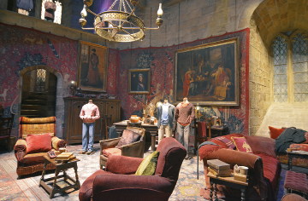 | 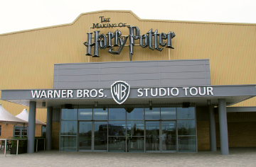  1
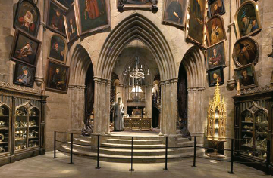 | 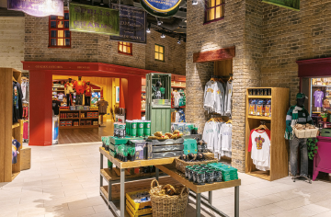
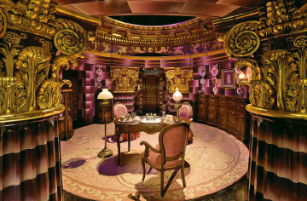  Professor Umbridge’s  office | 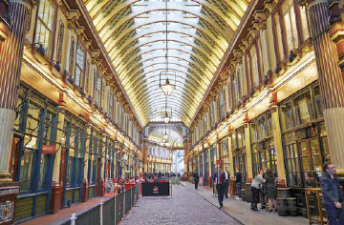
D. Complete the sentences using ONE word in each gap, according to the text.
1. Jackie’s school has spacious ___________, labs, a fantastic library and a giant ___________.
2. They arrived in historic Oxford at ___________ a.m.
3. They felt __________, ___________ and ___________ were right behind them during the ___________.
4. Jackie liked Professor Umbridge’s __________ because it’s the only __________ room in Hogwarts.
5. Jackie went to the ___________ shop before leaving.
6. She really wanted to buy a ___________ in the souvenir shop.

