Unit 4
Reading Worksheet
4A6
Name No.: ______ Class: ________ Date: _____/ _____/ _____
Read the text.
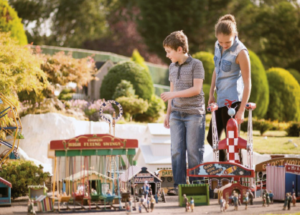


A day in Bekonscot!
Eve
Gabriel
5  10  15  20  25 | The first time I asked my mother to visit it I  was 5 years old… Now, 8 years later, I finally went  to Bekonscot Model Village and Railway, the  world’s oldest model village, located in South  East England. There are more than 200 buildings,  3,000 tiny people living their daily lives, 1,000  animals and hundreds of vehicles.  I went with my parents and my younger brother,  Gabriel, and we had an amazing visit (the only one  that stayed at home was our dog, Twinkie, as pets  are not allowed). Inside Bekonscot there are seven  little towns, but my favourite ones were Greenhaily  and Bekonscot Town.  In Greenhaily we saw Chessnade Zoo with model penguins, elephants, tigers, lions and even a  chimps’ tea party. In this little town there was also a castle. I visited it with my mother while my  father and brother were counting how many different animal species there were.  Bekonscot Town is the oldest part of the village. We could see a cinema, two railway stations,  a fire station and four pubs. When we were walking along the streets we visited a circus and the  world’s smallest Marks & Spencer (one of the most famous department stores in the UK).  My brother Gabriel loves trains, so this was the ideal place for him. The two of us went on a  small train to get to know the village and he could see many models of different trains. While I  was trying to take some photos, my brother was behind me desperately trying to ruin all of them.  He wanted me to see all those trains attentively! The train stopped at a large outdoor area with a  café where my parents were waiting for us. After a day spent in Bekonscot, it was time to go. This  was a fantastic family day out in a wonderful little world.
A. Look at the pictures and tick (✓) the places that are NOT mentioned in the text.
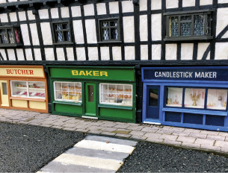  1 | 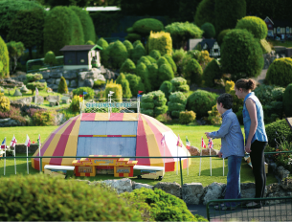  2 | 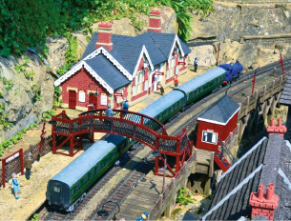  3
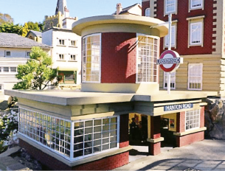  4 | 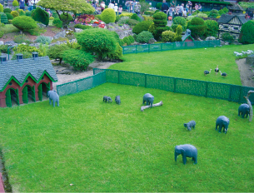  5 | 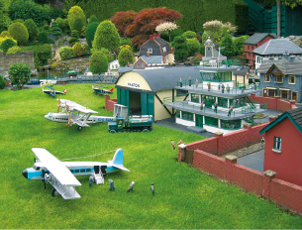  6

B. Look at these signs and notices. Tick (✓) the ones can you find in Bekonscot Model Village.
  1 | 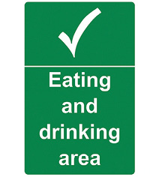  2 |  | 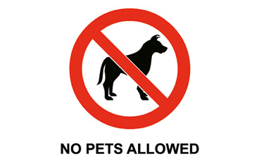  3
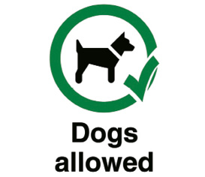  4 |  |   5 |  | 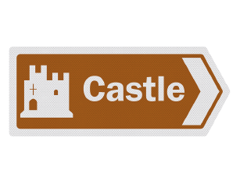  6
C. Match the columns to make true sentences. Write the letters a-f.
1. Eve was five when… a) in South East England.

2. Eve is… b) Greenhaily and Bekonscot Town.

3. Bekonscot Model Village is… c) thirteen years old.

4. It has… d) she first asked her mother to go to Bekonscot.

5. The family’s pet dog… e) many buildings, people, animals and vehicles.

6. Eve’s favourite towns were… f) didn’t go with them.

D. Answer the questions about the text. Give complete answers.
1. Who did Eve go to Bekonscot with?

2. What did they see in Greenhaily?

3. Was Eve’s mother also counting the animal species?

4. Why was Bekonscot the ideal place for Gabriel?

5. What was Gabriel doing while Eve was trying to take photos?

6. Where were Eve and Gabriel’s parents waiting for them after the train trip?

