Unit 4
Reading Worksheet
4B6
Name No.: ______ Class: ________ Date: _____/ _____/ _____
Read the text.
 | A day in Bekonscot!
5  10  15  20  25 | 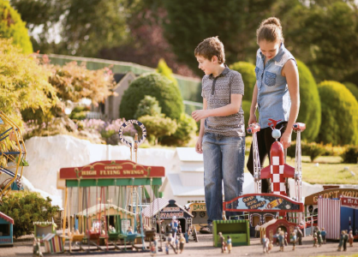      The first time I asked my mother to visit it I  was 5 years old… Now, 8 years later, I finally went  to Bekonscot Model Village and Railway, the  world’s oldest model village, located in South  East England. There are more than 200 buildings¹,  3,000 tiny people living their daily lives, 1,000  animals and hundreds of vehicles.  Eve  Gabriel  I went with my parents and my younger brother,  Gabriel, and we had an amazing visit (the only one  that stayed at home was our dog, Twinkie, as pets  are not allowed). Inside Bekonscot there are seven  little towns, but my favourite ones were Greenhaily  and Bekonscot Town.  In Greenhaily we saw Chessnade Zoo with model penguins, elephants, tigers, lions and even a  chimps’ tea party. In this little town there was also a castle. I visited it with my mother while my  father and brother were counting how many different animal species there were.  Bekonscot Town is the oldest part of the village. We could see a cinema, two railway stations,  a fire station and four pubs. When we were walking along the streets we visited a circus and the  world’s smallest Marks & Spencer (one of the most famous department stores in the UK).  My brother Gabriel loves trains, so this was the ideal place for him. The two of us went on a  small train to get to know the village and he could see many models of different trains. While I  was trying to take some photos, my brother was behind me desperately trying to ruin all of them.  He wanted me to see all those trains attentively! The train stopped at a large outdoor area with a  café where my parents were waiting for us. After a day spent in Bekonscot, it was time to go. This  was a fantastic family day out in a wonderful little world.
 | Vocabulary: ¹ buildings = edifícios.
A. Look at the pictures and tick (✓) the places that are mentioned in the text.
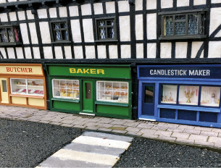  1 | 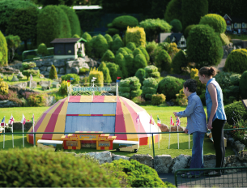  2 | 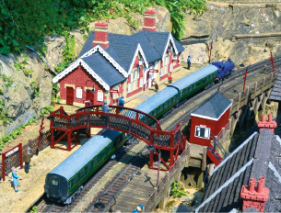  3
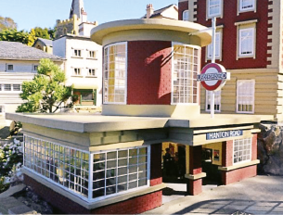  4 | 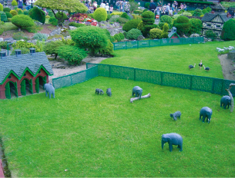  5 | 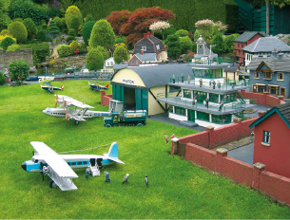  6

B. Look at these signs and notices. Tick (✓) the ones can you find in Bekonscot Model Village.
  1 | 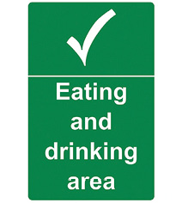  2 |  | 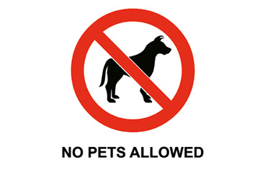  3
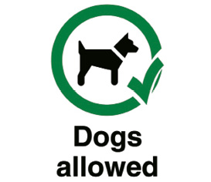  4 |  |   5 |  | 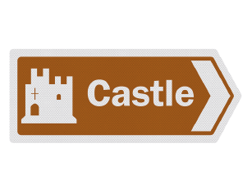  6
C. Match the columns to make true sentences. Write the letters a-e.
1. Eve was five when… a) in South East England.

2. Eve is… b) Greenhaily and Bekonscot Town.

3. Bekonscot Model Village is… c) thirteen years old.

4. It has… d) she first asked her mother to go to Bekonscot.

5. Eve’s favourite towns were… e) many buildings, people, animals and vehicles.

D. Tick (✓) the best answer to the questions below, according to the text.
1. Who did Eve go to Bekonscot with?
a) Eve went with her parents and her brother, Gabriel.

b) Eve went with her parents, her brother, Gabriel, and her dog, Twinkie.

2. What did they see in Greenhaily?
a) They saw Chessnade Zoo and a pub in Greenhaily.

b) They saw Chessnade Zoo and a castle in Greenhaily.

3. Why was Bekonscot the ideal place for Gabriel?
a) Bekonscot was the ideal place for Gabriel because he loves trains.

b) Bekonscot was the ideal place for Gabriel because he loves the circus.

4. What was Gabriel doing while Eve was trying to take photos?
a) Gabriel was trying to take photos himself.

b) Gabriel was trying to ruin Eve’s photos.

5. Where were Eve and Gabriel’s parents waiting for them after the train trip?
a) Eve and Gabriel’s parents were waiting for them at a large outdoor area with a café.

b) Eve and Gabriel’s parents were waiting for them at a large outdoor area with a garden.

