Unit 5
Reading Worksheet
5B6
Name No.: ______ Class: ________ Date: _____/ _____/ _____
These teens are talking about their future and how they see it. Read what they say about it.
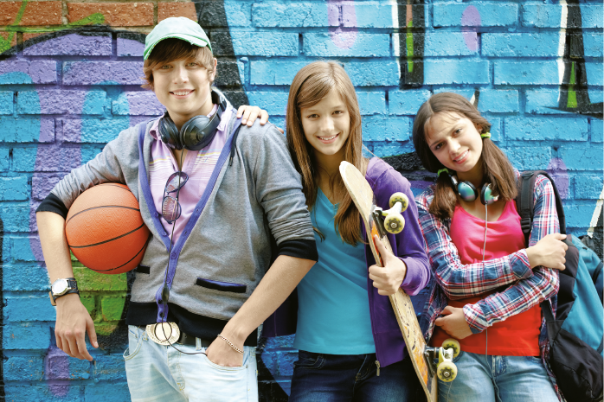
How do you see the future?
Justin
Brianna
Claire
I’m sure I’ll get a good job! I think I’ll work for some years and then I will travel the world,
as travelling is my passion. I want to see lots of different countries and meet lots of different
people. The only problem is that I hate flying, so I hope electric water bikes or cars will make
part of our future lives. I will miss my family, of course, so we will all communicate daily using
electronic jewellery (I love fancy earrings) which can detect my thoughts and send a virtual hug
or kiss to my parents and sister.
Claire
I’m only 14, but I already know that, in a few years, I’m going to keep playing video games and be
a famous YouTuber. Oh, and I will be able to watch football matches in 3D on my bedroom giant
screens. It will be awesome to have a football star playing in front of me.
As for me, there won’t be any television sets and everyone will watch TV on their own computers.
This will be incredible as there will be no arguments in people’s houses when they want to watch
different programmes, as it happens now between me and my brother!
Justin
I want to be a dancer and if I’m lucky, I will take part in movies like High School Musical and other
famous TV series that involve dancing. After all, all I want is to be famous – my greatest desire!
I also like writing, so I’m going to write a book about my life in the world of fame. I already have
an idea about how it’s going to be: a book in the form of a hologram! Isn’t that an awesome idea?
Brianna

A. Find opposites in bold for the following words in Claire and Justin’s texts.
1. hate (Claire’s text) ≠
2. same (Claire’s text) ≠
3. real (Claire’s text) ≠
4. terrible (Justin’s text) ≠
5. tiny (Justin’s text) ≠
6. no one (Justin’s text) ≠
B. Which picture refers to the future which each of these teens predicts? Write their names (Claire, Brianna or Justin) under the pictures.
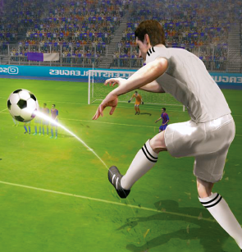 |  | 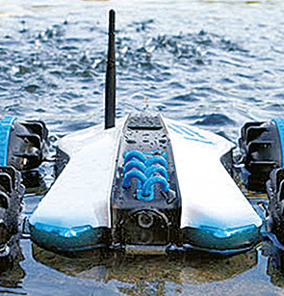
1. | 2. | 3.
C. Read the sentences and tick (✓) Yes or No. Yes No
1. Having a great professional career is something Claire predicts for her future.

2. Claire hates travelling and that’s her only problem.

3. Justin is young, but he is quite sure about what he is going to be in the future.

4. He doesn’t like technology very much, so he won’t use any technological devices.

5. Brianna wants to participate in all types of films.

D. Match the two columns. Write a-f.
1. Claire’s passion.  2. Device Claire is going to use  to communicate with her family.  3. What Justin is going to be in the future.  4. Reason why having a personal  computer at home will be great.  5. Brianna’s biggest dream for the future.  6. How Brianna’s book is going to look like. | a) A famous YouTuber.  b) To be famous.  c) Travelling.  d) Electronic jewellery.  e) A hologram.  f) No arguments in people’s houses  when they want to watch different  programmes.

