Name: ___________________________ Class: _____ No.: _____ Date: ___________ Teacher: _____________________
Reading | Mark: ____________________ Language | Mark: ____________________ Enc. Educação: ___________

Reading and Language Test 1B – Year 7

I – Reading (15 minutes)

Read the magazine article carefully.
Shanice & Andrea – a day in their lives

12-year-old identical twins Shanice and Andrea Nyandoro are the winners of The Voice Kids UK 2023. These twins from Leicester are difficult to distinguish¹ as they have got the same long black hair, the same eye colour and the same smile. Be careful because you never know who is who!

5

10

Andrea
Do you want to know what their day is like? Well, they don’t sing all day, but most of it! They get up really early, at 6.30 a.m. because they have to catch the bus to school. They never leave home without having breakfast. Classes start at 8 a.m. They only have classes in the morning, so they never have lunch in the school canteen. They have lunch at home with their father. In the afternoon, guess what they do after they do homework? They sing and sing… They practise new songs and sometimes they write their own lyrics, too. They also post videos with their songs and dance moves on TikTok. At 8 p.m. dinner is ready. They help their mother and after dinner they listen to some music. At 10 p.m. it is time to go to bed. Their day is about to get very busy after winning this prize, but their biggest dream is to continue singing. As their coach Will.i.am says: “They are the Wonder Twins.”
Shanice
Vocabulary: ¹distinguish = distinguir

- Three sentences are false and only ONE is true. Read the sentences and tick () True or False.
 | True | False
- Shanice and Andrea’s hair is long and fair.
- They go to school by bus.
- They never have breakfast at home.
- They sometimes have classes all day.

- Complete the answers to the questions.

- What time do the twins Shanice and Andrea get up?
The twins Shanice and Andrea get up at __________________________.
- Who do they have lunch with?
They have lunch with their _________________.
- Where do they post their songs and dances?
They post their songs and dances on __________________.
- What do they do after dinner?
They __________________________ after dinner.

II – Language (25 minutes)

- Choose the correct contestant’s name of The Voice Kids 2023 to complete the physical descriptions.
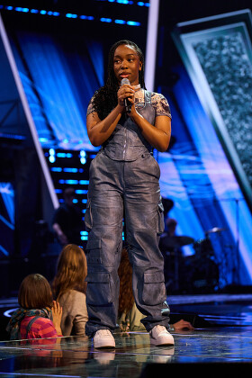


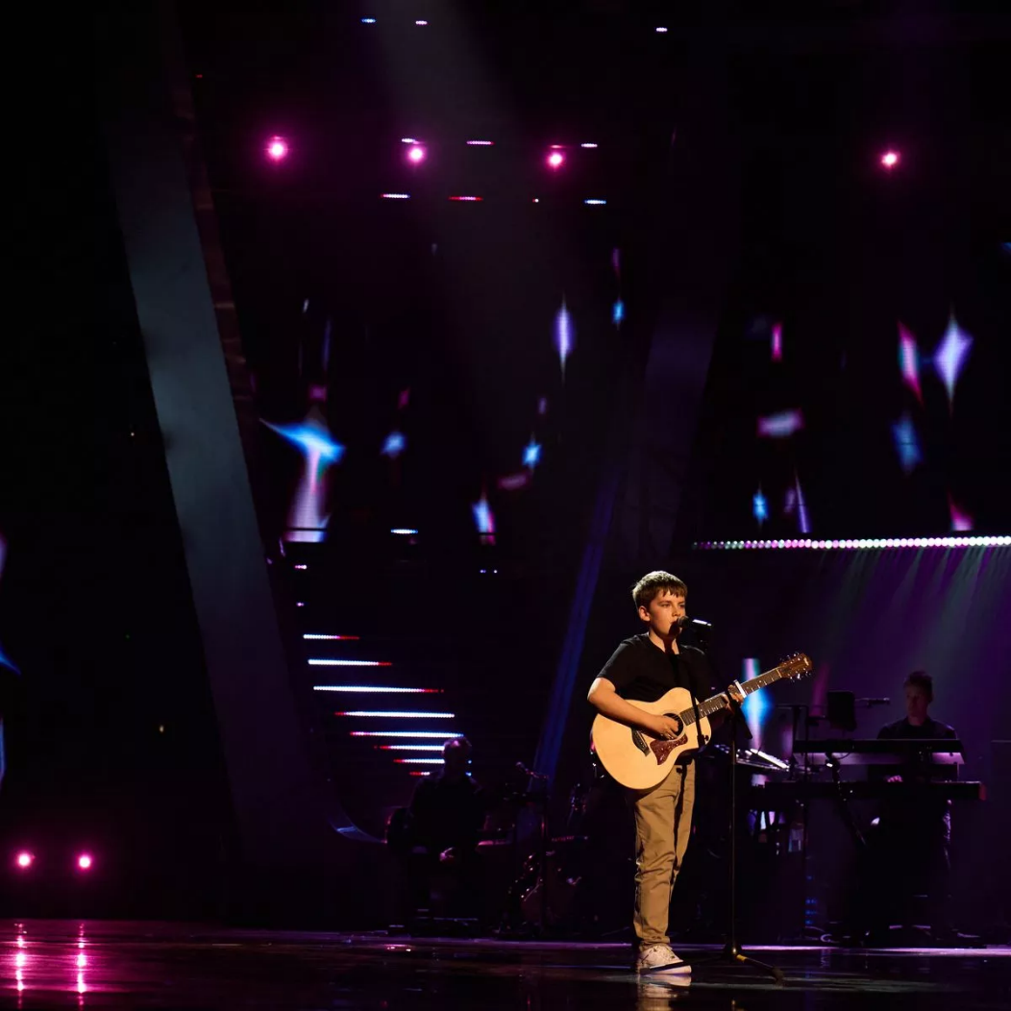
Elim
Abigail
Armari
Jarlaith

- Abigail / Elim is medium height and slim. She has got straight brown hair and fair skin.
- Armari / Jarlaith is short and thin. He has got short straight hair and brown eyes.
- Elim / Abigail is tall. She has got long dark hair and dark skin.
- Jarlaith / Armari is medium height and a bit fat. He has got short curly hair and brown eyes.

- Look at the pictures of Elim’s daily routine activities. What time is it? Circle the correct time.

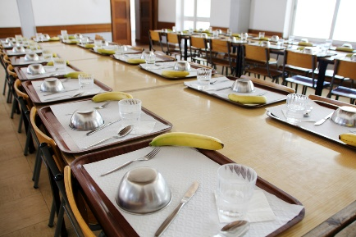
4:20 p.m.
12:30

1. It’s half past twelve / a quarter past twelve. 2. It’s twenty to four / twenty past four.


10 p.m.
5:15 p.m.

3. It’s a quarter past five / half past five. 4. It’s ten o’clock / eleven o’clock.

- Look at the pictures from exercise B. Correct the wrong information underlined in the sentences with the words/expressions from the box.
by bus
does her homework
lunch
goes to bed
  - Elim has breakfast in the school canteen. _____________________
  - She goes home on foot. ___________________________
  - She has lunch in the bedroom. ___________________________
  - She watches TV at 10 p.m. ______________________________
- Choose the correct possessive determiners to complete the sentences.

  - Shanice and Andrea are twins. Your / Their eyes are dark.
  - Jarlaith is from Belfast, Northern Ireland. Her / His sister is called Jessica.
  - Abigail hasn’t got any siblings. Her / Their father supports her a lot.
  - My friend Gina and I are great fans of The Voice Kids. Their / Our favourite contestant is Elim.

- Choose the correct forms of the verbs to be or have got to complete the text.
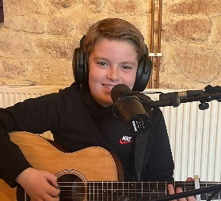
Jarlaith Mervyn ¹ has got / is twelve years old and he ² is / are from Belfast.
He ³ is / has got an older sister, Jessica. She ⁴ is / has got his idol because she also sings and plays really well. They ⁵ aren’t / haven’t got many friends outside school because their life ⁶ is / are very busy, but they ⁷ has got / have got each other. Jarlaith doesn’t play on the streets of Belfast anymore, but he ⁸ isn’t / aren’t the type of boy who forgets his roots! Belfast ⁹ has got / is always in his ♥!
¹⁰ Are / Is you curious to know more about him? Check his Instagram…

- Fill in the gaps with the correct possessive pronouns: theirs; hers; yours; his.

  - “Your clothes are lovely. Are they really _________ or do they belong to the show?”
  - Jarlaith’s guitar is yellow, so that brown one isn’t _________.
  - They don’t have original songs. Those songs aren’t __________.
  - Abigail hates black, so that black dress isn’t _______. I’m sure!

- Order the words to make correct sentences. There is one example.
- Andrea / never / late / gets up
Andrea never gets up late.

_______________________________________________________________________
- Shanice and Andrea / go / always / by bus / to school / .
_______________________________________________________________________
- They / are / late for school / never /.
_______________________________________________________________________
- Armari / sings / often / his own rap songs / .
_______________________________________________________________________
- Elim / until late / doesn’t study / .
_______________________________________________________________________
- The Voice Kids / Do you and Rob watch / ?
_______________________________________________________________________
- her life / Does Abigail enjoy / ?
_______________________________________________________________________
Good work!
Your teacher
Year 7 – Reading and Language test 1B

Answer key

I – Reading
A. (4 x 10% = 40%)
1. F | 2. T | 3. F | 4. F
B. (4 x 15% = 60%)
1. 6.30 a.m. (half past six a.m.) | 2. father | 3. TikTok | 4. listen to (some) music

II – Language
A. (4 x 2% = 8%)
1. Abigail | 2. Jarlaith | 3. Elim | 4. Armari
B. (4 x 2% = 8%)
1. half past twelve | 2. twenty past four | 3. a quarter past five | 4. ten o’clock
C. (4 x 2% = 8%)
1. lunch | 2. by bus | 3. does her homework | 4. goes to bed
D. (4 x 2% = 8%)
1. Their | 2. His | 3. Her | 4. Our
E. (10 x 2% = 20%)
1. is | 2. is | 3. has got | 4. is | 5. haven’t got | 6. is | 7. have got | 8. isn’t | 9. is | 10. Are
F. (4 x 3% = 12%)
1. yours | 2. his | 3. theirs | 4. hers
G. (6 x 6% = 36%)
1. Shanice and Andrea always go to school by bus. | 2. They are never late for school. | 3. Armari often sings his own rap songs. | 4. Elim doesn’t study until late. | 5. Do you and Rob watch The Voice Kids? | 6. Does Abigail enjoy her life?

