Name: ___________________________ Class: _____ No.: _____ Date: ___________ Teacher: _____________________
Reading | Mark: ____________________ Language | Mark: ____________________ Enc. Educação: ___________

Reading and Language Test 1C – Year 7

I – Reading (15 minutes)

Read the magazine article carefully.
Shanice & Andrea – a day in their lives

12-year-old identical twins Shanice and Andrea Nyandoro are the winners of The Voice Kids UK 2023. These twins from Leicester are difficult to distinguish¹ as they have got the same long black hair, the same eye colour and the same smile. Be careful because you never know who is who!

5

10

Andrea
Do you want to know what their day is like? Well, they don’t sing all day, but most of it! They get up really early, at 6.30 a.m. because they have to catch the bus to school. They never leave home without² having breakfast. Classes start at 8 a.m. They only have classes in the morning, so they never have lunch in the school canteen. They have lunch at home with their father. In the afternoon, guess what they do after they do homework? They sing and sing… They practise new songs and sometimes they write their own lyrics, too. They also post videos with their songs and dance moves on TikTok. At 8 p.m. dinner is ready. They help their mother and after dinner they listen to some music. At 10 p.m. it is time to go to bed. Their day is about to get very busy after winning this prize, but their biggest dream is to continue singing. As their coach Will.i.am says: “They are the Wonder Twins.”
Shanice
Vocabulary: ¹ distinguish = distinguir; ² without = sem

- Three sentences are false and only 1 is true. Read the sentences and tick () True or False.
 | True | False
- Shanice and Andrea’s hair is long and fair.
- They go to school by bus.
- They never have breakfast at home.
- They sometimes have classes all day.


- Complete the answers to the questions.

- What time do the twins Shanice and Andrea get up?
The twins Shanice and Andrea get up at _______________________.
What time? = A que horas?
Who… with? = Com quem?
Where? = Onde?
What? = O quê?
- Who do they have lunch with?
They have lunch with their ________________.
- Where do they post their songs and dances?
They post their songs and dances on __________________.
- What do they do after dinner?
They _________________ after dinner.

II – Language (25 minutes)

- Choose the correct contestant’s name of The Voice Kids 2023 to complete the physical descriptions.



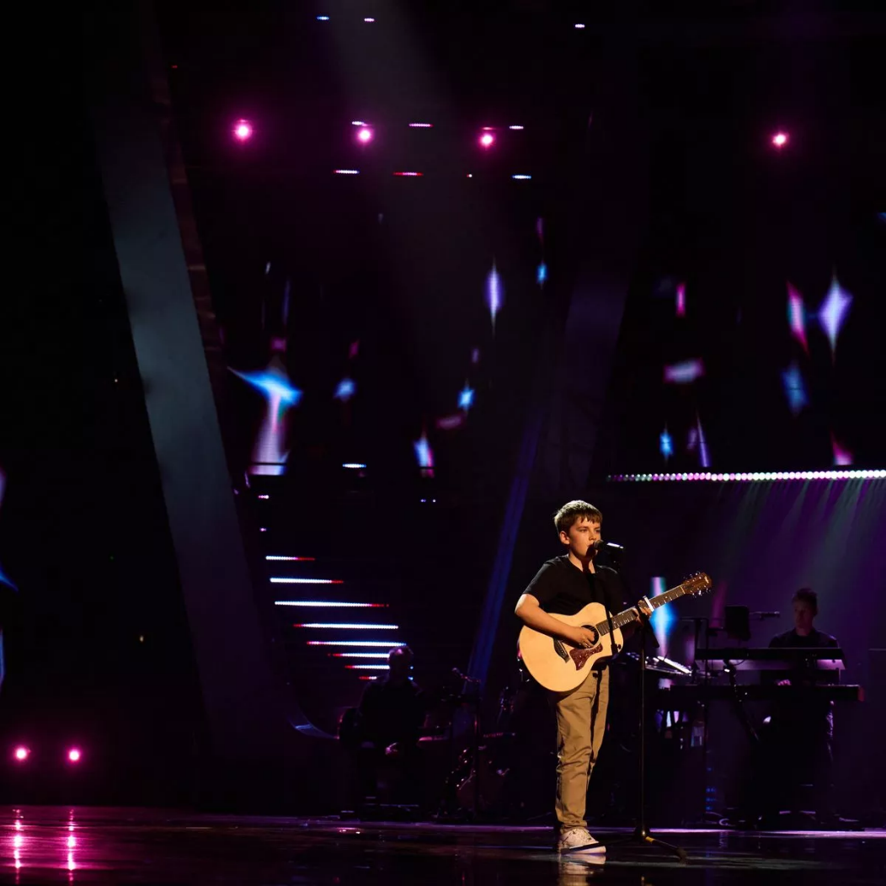
Elim
Abigail
Armari
Jarlaith


  - Abigail / Elim is medium height and slim. She has got straight brown hair and fair skin.

  - Armari / Jarlaith is short and thin. He has got short straight hair and brown eyes.


  - Elim / Abigail is tall. She has got long dark hair and dark skin.
  - Jarlaith / Armari is medium height and a bit fat . He has got short curly hair and brown eyes.

- Look at the pictures of Elim’s daily routine activities. What time is it? Circle the correct time.

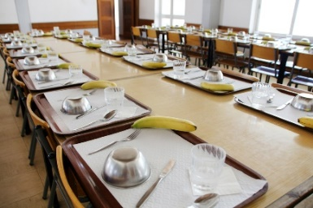

10 p.m.
5:15 p.m.
12:30
4:20 p.m.

1. It’s half past twelve / a quarter past twelve. 2. It’s twenty to four / twenty past four.


3. It’s a quarter past five / half past five. 4. It’s ten o’clock / eleven o’clock.
It’s… o’clock.


It’s five to…
It’s five past…
It’s a quarter to…
It’s a quarter past…
It’s twenty-five to…
It’s twenty to…
It’s ten to…
It’s half past…
It’s twenty-five past…
It’s twenty past…
It’s ten past…

- Choose the correct possessive determiners to complete the sentences.

Possessive determiners

Personal pronouns

- Shanice and Andrea are twins. Your / Their eyes are dark.
my
your
his
her
its
I
you
he
she
it

Singular
Singular
- Jarlaith is from Belfast. Her / His sister is called Jessica.
- Abigail hasn’t got any siblings. Her / Their father supports her a lot.
- My friend Gina and I are great fans of The Voice Kids. Their / Our favourite contestant is Elim.
Plural
we
you
they

our
your
their

Plural

- Choose the correct forms of the verbs to be or have got to complete the text.
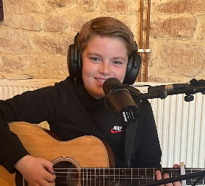
Jarlaith Mervyn ¹ has got / is twelve years old and he ² is / are from Belfast.
to be = ser/estar
(am; is; are)

have got = ter
(have got; has got)
He ³ is / has got an older sister, Jessica. She ⁴ is / has got his idol because she also sings and plays really well. They ⁵ aren’t / haven’t got many friends outside school because their life ⁶ is / are very busy, but they ⁷ has got / have got each other. Jarlaith doesn’t play on the streets of Belfast anymore, but he ⁸ isn’t / aren’t the type of boy who forgets his roots! Belfast ⁹ has got / is always in his ♥!
¹⁰ Are / Is you curious to know more about him? Check his Instagram…

- Order the words to make correct sentences. There is one example.
- Andrea / never / late / gets up
Andrea never gets up late.

__________________________________________________________
Adverbs of frequency (position)
Subject + adverb of frequency + main verb

Subject + verb to be +
adverb of frequency

- Shanice and Andrea / go / always / by bus / to school / .
__________________________________________________________
- They / are / late for school / never /.
__________________________________________________________
- Armari / sings / often / his own rap songs / .
__________________________________________________________
- Elim / until late / doesn’t study / .
__________________________________________________________
- The Voice Kids / Do you and Rob watch / ?
__________________________________________________________
Good work!
Your teacher
- her life / Does Abigail enjoy / ?
__________________________________________________________
Year 7 – Reading and Language test 1C

Answer key

I – Reading
A. (4 x 10% = 40%)
1. F | 2. T | 3. F | 4. F
B. (4 x 15% = 60%)
1. 6.30 a.m. (half past six a.m.) | 2. father. | 3. TikTok. | 4. listen to (some) music

II – Language
A. (4 x 2% = 8%)
1. Abigail | 2. Jarlaith | 3. Elim | 4. Armari
B. (4 x 2% = 8%)
1. half past twelve | 2. twenty past four | 3. a quarter past five | 4. ten o’clock
C. (4 x 2% = 8%)
1. Their | 2. His | 3. Her | 4. Our
D. (10 x 4% = 40%)
1. is | 2. is | 3. has got | 4. is | 5. haven’t got | 6. is | 7. have got | 8. isn’t | 9. is | 10. Are
E. (6 x 6% = 36%)
1. Shanice and Andrea always go to school by bus. | 2. They are never late for school. | 3. Armari often sings his own rap songs. | 4. Elim doesn’t study until late. | 5. Do you and Rob watch The Voice Kids? | 6. Does Abigail enjoy her life?

