25 minutes

Imagine you want to participate in a talent show.
Write an email (35-50 words) to the show managers introducing yourself. Mention the following:
- your talent (e.g.: singing; dancing; playing…; acting; making…);

- your name; age; family;
- your daily routine (morning; afternoon; evening activities).
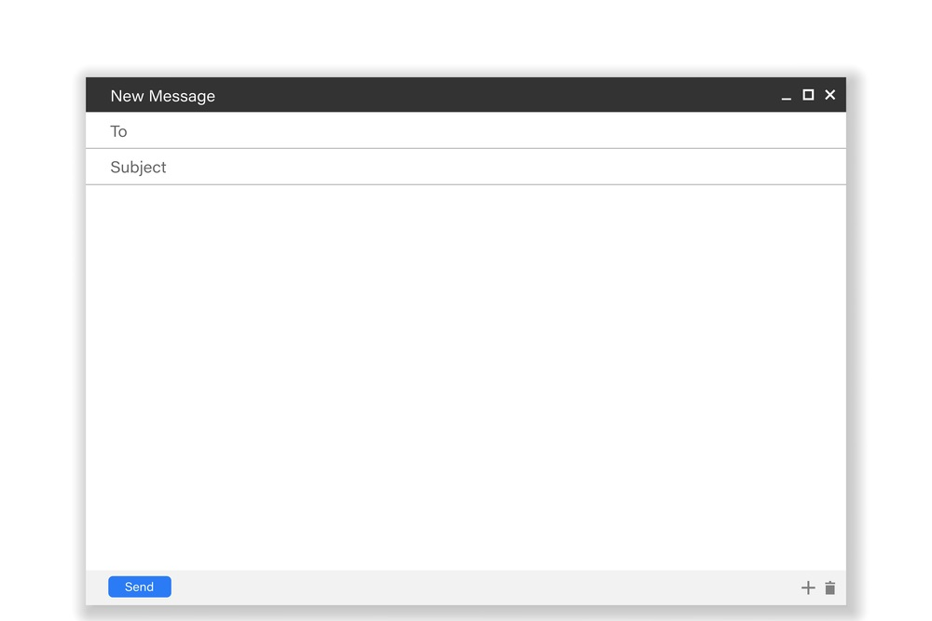

Dear Sirs,

My talent is ____________________________________________________________________________________
______________________________________________________________________________________________
______________________________________________________________________________________________
____________________________________________________________________________________________________________________________________________________________________________________________
____________________________________________________________________________________________________________________________________________________________________________________________
______________________________________________________________________________________________
______________________________________________________________________________________________

Yours faithfully,
____________________________

Good work!
Your teacher

Year 7 – Writing Test 1A
Answer key
Suggested answer:
Dear Sirs,
My talent is playing the drums.
I’m George and I’m 11 years old. I live with my parents and my brother.
In the morning I have classes until midday. Then, I go home and I have lunch. I do my homework and I practise playing the drums. After dinner I play video games. I go to bed at 10.30 p.m.

Yours faithfully,
George

