25 minutes



Imagine you want to participate in a talent show.
Complete the email to the show managers introducing yourself.
The expressions/words from the box below may help you.

Morning | Afternoon | Evening
brush my teeth = lavar os dentes  get dressed = vestir-se  get up = levantar-se  go to school = ir para a escola  have a shower = tomar duche  have breakfast = tomar o pequeno-almoço  have classes = ter aulas | do homework = fazer o trabalho de casa  finish classes = terminar as aulas  go to football practice = ir ao treino de futebol  go to the study centre = ir para o centro de estudos  go home = ir para casa  have lunch = almoçar | go to bed = ir para a cama  have dinner = jantar  play video games = jogar videojogos  study = estudar  watch TV = ver televisão
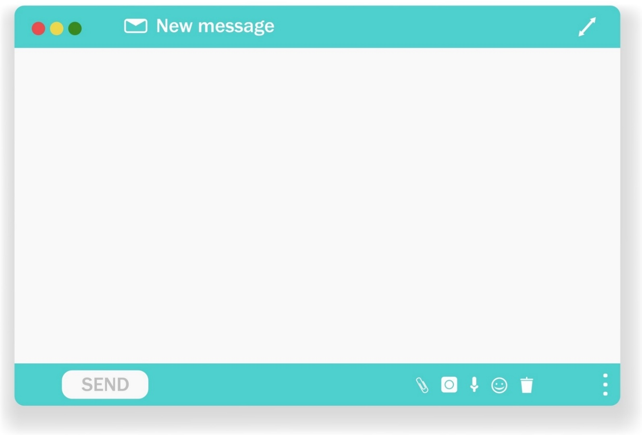

Dear Sirs,
My talent is ¹ ______________________ (e.g.: singing; dancing; playing…; acting; making…).
I’m ² ___________________ (name) and I’m ³ _____________ (age) years old. I live with my ⁴ _________________
____________________________________________________________________ (family members).
In the morning I ⁵ ______________________________________________________________________________ ________________________________________________________ (3 morning activities).
In the afternoon I ⁶ _____________________________________________________________________________ _________________________________________________________ (3 afternoon activities).
In the evening I ⁷ ______________________________________________________________________________ _________________________________________________________ (3 evening activities).

Yours faithfully,
⁸ ____________________________ (your name)

Good work!
Your teacher

Year 7 – Writing Test 1B
Answer key
Suggested answers:
1. playing the drums | 2. George | 3. 11 | 4. parents and my brother | 5. have breakfast, go to school and have classes until midday | 6. go home, have lunch and finish classes | 7. play video games, have dinner and go to bed | 8. George

