
A. Circle the correct option to complete the dialogue.

Get ready for the tests
Name No.: _____ Class: _______ Date: ____/ ____/ ____
Mark: ________________ Teacher ____________________________ Enc. Educação
1
Gaten: What’s your ¹ name / surname?
Maya: My surname is Spencer. How ² old / tall are you?
Gaten: I ³ ’m / ’ve got 11 years old. When is your ⁴ school / birthday?
Maya: It’s ⁵ on / in 12th April. Where are you from?
Gaten: I’m from ⁶ Canada / Canadian, so I’m ⁷ Canada / Canadian. And you?
Maya: I’m from ⁸ American / the USA, so I’m ⁹ American / the USA. What’s your ¹⁰ occupation / nationality?
Gaten: I’m a student.
B. Unscramble the words and write the family members.
1. HRFAET 5. UICOSN
2. OTERMH 6. MEGROTHANDR
3. ISSRTE 7. NETSPAR
4. ANTU 8. NCULE
C. Look at the pictures of Fortnite skins and circle the correct option to complete the sentences.
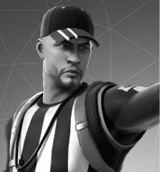  1 | 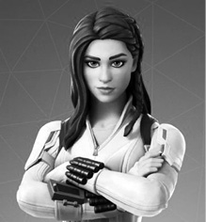  2 | 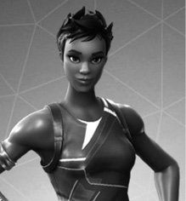  3 | 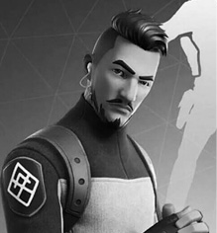  4
1. He has got an oval / round face. He has got a beard / freckles and he is wearing glasses / a cap.
2. She has got short / long hair. She has got green eyes and her skin is fair / dark.
3. She has got short / long hair and her skin is dark / fair.
4. He has got a big mouth / nose. His hair / head is short and he has got a cap / moustache.
D. Match the two columns and write the daily routine activities. Write the letters a-f.

1. brush a) your hair

2. comb b) to school

3. have c) your teeth

4. play d) up

5. get e) classes

6. go f) video games

E. Complete the table with the missing words.
Personal pronouns | Possessive determiners | Possessive pronouns
I | 6. | mine
1. | your | 11.
he | 7. | 12.
2. | 8. | hers
3. | Its | 13.
we | 9. | 14.
4. | 10. | yours
5. | their | 15.
F. Complete the sentences with pronouns/determiners from exercise E.
1. This is Natalia and this is _____________ father.
2. David and _____________ family live in the UK. _____________ have got a big house.
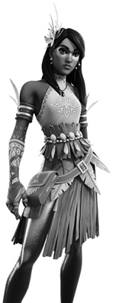
3. “Is this _____________ pen, Noah?” “No, _____________ isn’t. It belongs to Paul – it’s _____________.”
4. _____________ house is small, but we love it! The house is _____________.
5. I can’t borrow the book because it isn’t _____________. The book is Mathew’s – it’s _____________.
G. Complete the text with the verbs to be or have got.
Kalia
(Fortnite)
Hi! My name is Francesca and I ¹_____________ a new Fortnite skin. Her name
²__________ Kalia and she ³__________ very exotic. Kalia and I ⁴__________ very different.
She ⁵_____________ brown hair, but my hair ⁶_____________ (not) brown – it
⁷_____________ red. Her hair ⁸_____________ straight, but I ⁹_____________ curly hair.
I ¹⁰_____________ medium height, but she ¹¹_____________ tall. She ¹²_____________
very beautiful and… so am I! J
H. Put the words in order and write sentences. Write the verbs in the present simple.
We have lunch at midday.
• at midday / have / lunch / We / .
1. very early / start / My classes / .
2. by bus / not go / Charlie / to school / .
3. have / My friends / in the canteen / lunch / .
4. study / you / at home / ?
5. video games / not play / Randall / .
6. in the morning / she / comb her hair / ?
7. she / Yes, / do / .
I. Rewrite the sentences. Put the adverbs of frequency in the correct place.
1. We go to school by car. (sometimes)
2. They are at home at the weekends. (often)
3. Joseph reads a book before bed. (always)
4. The teachers are late for classes. (hardly ever)

