A. This is John’s bedroom. Which objects are there in John’s bedroom. Write the letters a-h.

Get ready for the tests
Name No.: _____ Class: _______ Date: ____/ ____/ ____
Mark: ________________ Teacher ____________________________ Enc. Educação
2
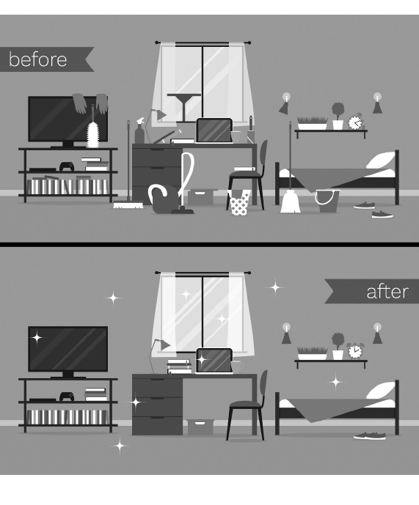




1. window 5. chair
a)
b)
c)
d)
e)
f)
g)
h)

2. pillow 6. curtains

3. bed 7. desk

4. lamp 8. bookshelf

B. What chores does John do? Tick (✓) the correct options.
1. tidy up

2. do the washing up

3. vacuum the floor

4. mop the floor

5. dust the furniture

6. do the ironing

7. sweep the floor

8. cut the grass

9. clear the table

C. Write the rooms of the house that match the furniture.
dining room
• table; chairs; lamp 3. washbasin, bath, toilet
1. sink; cupboard; fridge 4. chest of drawers, bed, wardrobe
2. sofa, armchair, coffee table
D. Write the -ing forms of the verbs.
playing
• play 4. enjoy
1. do 5. have
2. make 6. wash
3. shop
E. Complete the sentences with the correct form of the verbs in brackets. Use the present continuous.
1. She _______________________ (do) her homework.
2. I _______________________ (brush) my teeth at the moment.
3. Now they _______________________ (ride) their bikes.
4. My sister _______________________ (not drink) juice. She _______________________ (drink) tea.
5. “_______________________ (you/have) fun at home today?” “No, _______________________.”

F. Complete the text with the present simple or present continuous of the verbs in brackets.
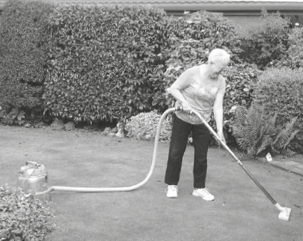
The Hudsons are a very funny family! Today ¹_________ (be)
Saturday. Now they ²_______________ (not clean) the house
inside – they ³___________________ (do) some chores outside.
Jack ⁴_____________ (sweep) the car – he ⁵_____________ (love)
his car! But we ⁶_____________ (not sweep) the car with
a broom, we usually ⁷_____________ (wash) it, right? Rose
⁸_____________ (vacuum) her favourite part of the house:
the garden! At least the garden is always clean! Ruth
and Tommy ⁹________________ (iron) the plants. Poor plants!
People usually ¹⁰_____________ (water) them or even clean
them, but they ¹¹_______ (not iron) them! Anyway, this is a
crazy family, so they always ¹²___________ (do) crazy things!
G. Tick (✓) the correct object pronoun to replace the underlined words/expressions.
1. Peter is reading a new book. | a) us | b) them | c) it
2. My sister likes John. | a) him | b) me | c) you
3. This present is for my parents. | a) me | b) them | c) her
4. Can you give those pencils to Tony and me? | a) it | b) us | c) him
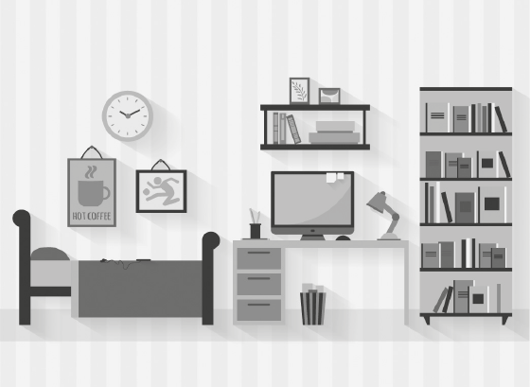
H. Read the sentences and write the numbers in the picture.

1. In the bookcase.
2. Under the desk.
3. Between the bed and the desk.
4. On the bed.
5. Above the clock.
6. Next to the lamp.
7. Behind the bed.
8. On the wall.

I. Use the words in the box to make six compound nouns and write them.
book | scraper | chair | shelf
bed | black | stair | board
case | arm | room | sky

1. 4.
2. 5.
3. 6.

