A. Read what Miles is saying and find out the school subjects. Write them next to the numbers 1-6 below.
1. What does “merci”
mean?

Get ready for the tests
Name No.: _____ Class: _______ Date: ____/ ____/ ____
Mark: ________________ Teacher ____________________________ Enc. Educação
3
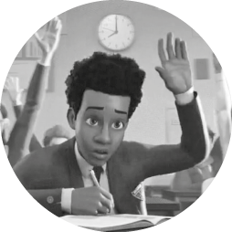
2. The capital of Poland is
Warsaw.
6. Brazil? It was discovered
by Pedro Álvares Cabral.
5. Teacher, I can’t solve
this equation…
4. I know! It’s a
metamorphic rock!
3. Can I play in Rick’s team?
1.______________ | 2.______________ | 3.______________ | 4.______________ | 5.______________ | 6.______________
B. Where in school can Miles Morales do these things? Write the school facilities.
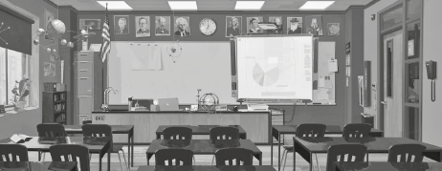
1. borrow a book
2. buy a new pencil
3. have classes
4. play football
5. have lunch
6. buy a snack
C. Complete the text with the past simple of the verb to be.

Shameik
Moore
Hi! My name is Shameik Moore and I’m the voice of Miles
Morales in the film Spider-Man: Into the Spider-Verse. When
I 1______________ younger, I 2______________ in Druid Hills High School,
in Georgia (USA). It 3______________ (not) a big school, but it
4______________ nice and the teachers 5______________ very friendly.
My friends and I 6______________ always in the sports field playing
basketball and when we 7_____________ (not) there, we 8______________
outside chatting and having fun. I miss those days…
D. Complete the table with the past simple of the verbs.
Regular verbs | Past simple |  | Irregular verbs | Past simple
1. play |  |  | 6. see
2. dance |  |  | 7. go
3. cry |  |  | 8. make
4. stop |  |  | 9. eat
5. wash |  |  | 10. swim

E. What did they do yesterday? Look at the pictures and complete the sentences with the correct past simple form of the verbs from the box.
read | chat | eat | take | buy | cook | drink | study

 |  | 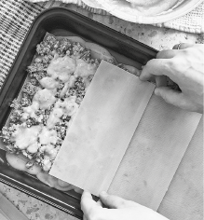 | 
1. The girls  in the café. | 2. Lucas  in his bedroom. | 3. Tom and Sarah  a delicious lasagne. | 4. The cat  his milk.
 | 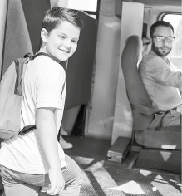 | 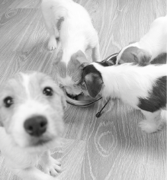 | 
5. Samantha  a new book. | 6. He  the bus to go to  school. | 7. The dogs  their food. | 8. My father  the newspaper.
F. Use the words to make sentences in the past simple.
I went to school last week.
• I / go / to school / last week / .
1. Yesterday she / be / at home / .
2. Paul / come / to the party, but he / not stay / long / .
3. He / do / his homework this afternoon / ?
4. The students / not study / enough for the test / .
5. My sister / take / a nice picture / .
6. Julie / not feed / the cat this morning / .

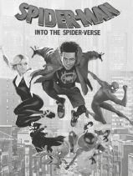
G. Circle the correct connector to complete the sentences.
1. I watched the latest Spider-Man film, but / or it wasn’t my favourite one.
2. I don’t usually watch films. However / So, I love Spider-Man films.
3. Do you prefer Spider-Man and / or Batman?
4. My brother is a Spider-Man fan. Therefore / Or, he watched all the films.

