
A. Unscramble the words to complete the text with city places.

Get ready for the tests
Name No.: _____ Class: _______ Date: ____/ ____/ ____
Mark: ________________ Teacher ____________________________ Enc. Educação
4

Cardi B
Hello! I’m Cardi B and I live in New York. It’s my favourite city in
the world! During the day, I love going to the ¹ PRKA ______________
and to the ² MINSMWIG POLO _________________________ to exercise
a little bit. I usually visit some ³ RTA EESGRIALL ___________________
and ⁴ UMUSSME _________________. There are lots of them in NY City!
In the evening I like to go out for dinner. There are lots of nice
⁵ ARANUTRESTS _____________________, so it’s difficult to choose!
After dinner I like going to the ⁶ ETHTREA _________________.
B. Label the city features.
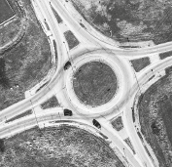 |  | 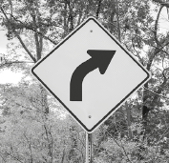 | 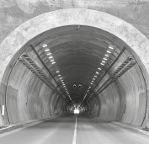 | 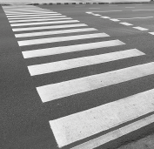
1.________________ | 2.________________ | 3.________________ | 4.________________ | 5.________________

C. Complete the city activities. The first letter is already given.

m
s
s
c
s
c
Sam Smith
Hi! I’m Sam Smith and I’m from London. It’s a big city
and there are lots of things we can do. I love going to the
¹___________________ with my friends to watch the latest movies.
I also go to ²___________________ very often because I love music.
When I need to buy some clothes, I go ³___________________ with
my sisters. I have some friends from other countries, so when
they come to London, we always go ⁴_______________, visit some
⁵_________________ and walk along the ⁶_________________ because
it’s a beautiful city.
D. Read the clues and write the names of the shops. “I never go to the supermarket, so…”
1. when I need to buy some bread, I go to the .
2. when I need to buy food for my dog, I go to the .
3. when I need to buy some fresh fish, I go to the .
4. when I need to buy the newspaper, I go to the .
5. when I need to buy fruit and vegetables, I go to the .
6. when I need to buy meat, I go to the .

E. What were they doing yesterday? Complete the sentences with the past continuous of the verbs in brackets.
1. They (do) their homework. 4. My parents (have) dinner
2. Lisa (not bake) a cake. 5. My friends (not walk) to school.
3. John (cook) dinner. 6. I (study) for the maths test.
F. Past simple or past continuous? Complete the sentences with the verbs in brackets.
1. The girl _______________ (run) when she _______________ (fall) and _______________ (break) her arm.
2. I _______________ (cook) dinner when she _______________ (arrive) home.
3. Sorry, I _______________ (not answer) because I ______________ (study) when you ______________ (call).
G. Look at the picture and answer the questions using the past continuous or past simple. Use the words/expressions from the box.
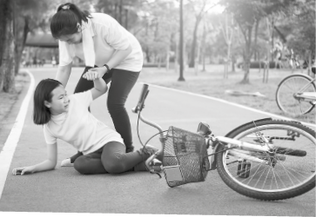
ride her bike | jeans and sweater | fall on the ground | help

1. What was the girl doing?
2. What clothes was she wearing?
3. Was she wearing a helmet?
4. What happened to her?
5. What did the woman do?
6. Did the woman run away?

H. Circle the correct modal verb to complete the sentences.
1. If you want to buy fish, you may / should go to the fishmonger’s.
2. Those clouds are really dark. It might / can’t rain.
3. I can’t / shouldn’t ride a bike. Can / Must you teach me?
4. At the library you may / must be quiet.
I. Tick (✓) the imperative sentences.
1. Turn right to go to the gym. | 3. Don’t walk on the grass.
2. She always turns right to go to the gym. | 4. John didn’t walk on the grass.
J. Choose the correct preposition of movement from the box to complete the sentences.
towards
across
through
into
1. I went ______________ the zebra crossing to get to the other side of the road.
2. I love going to the swimming pool, especially diving ______________ the water.
3. When I go to work, I always pass ______________ a tunnel.
4. When I arrive home, my dog always runs happily ______________ me. He’s so cute!

