A. What sports are these films about? Label the pictures with the names of the sports.

Get ready for the tests
Name No.: _____ Class: _______ Date: ____/ ____/ ____
Mark: ________________ Teacher ____________________________ Enc. Educação
5
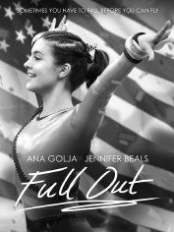 |  |  |  | 
1.________________ | 2.________________ | 3.________________ | 4.________________ | 5.________________
B. Complete the table with three sports from exercise A.
1. Play… | 2. Go… | 3. Do…
C. Match the two columns and write free time activities.
Colunn A | Column B | Free time activities
1. watching | a) selfies
2. listening | b) a bike
3. playing | c) videos
4. riding | d) board games
5. taking | e) to music
D. Find six summer activities in the word search and write them.
H | S | C | F | V | I | L | F | L | M | J | J | R | T | C | •______________________  •______________________  •______________________  •______________________  •______________________  •______________________
S | B | G | T | R | U | F | Q | X | A | J | P | C | M | I
U | S | B | O | J | T | E | E | W | R | B | S | S | M | A
R | N | Y | H | R | I | E | V | Z | D | T | B | C | I | F
F | O | O | F | W | G | F | I | S | H | I | N | G | E | I
I | R | F | X | V | F | F | D | M | B | M | F | W | A | F
N | K | W | U | P | K | E | U | U | N | L | V | W | W | S
G | E | U | W | Z | O | C | A | M | P | I | N | G | O | A
M | L | T | V | R | M | D | L | M | C | L | P | R | X | I
L | L | G | A | I | W | Y | A | I | S | Y | X | L | J | L
Y | I | H | N | F | K | H | A | R | M | Z | Q | Z | Q | I
A | N | O | K | O | J | L | W | F | Q | V | G | H | F | N
Z | G | Z | J | E | K | R | E | W | K | M | E | C | Y | G
I | O | J | Z | H | D | C | K | S | X | E | E | Q | V | O
N | S | U | N | B | A | T | H | I | N | G | S | K | M | D

E. What will she do when she has free time? Look at the pictures and write sentences with will + infinitive (affirmative or negative).
She will
  ✓ | 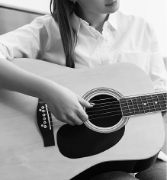  ✓ | 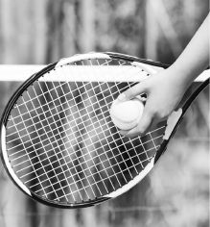  ✗ | 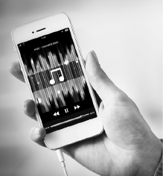  ✓
1.____________________ | 2.____________________ | 3.____________________ | 4.____________________
F. Complete the conditional sentences with the verbs in brackets. Then write Type 0 or Type 1.
1. If you heat water to 100 oC, it __________________ (boil).
2. If you __________________ (protect) the planet, you will have a better life.
3. If you like Italian food, you __________________ (love) this restaurant.
4. If you __________________ (put) water in the freezer, it freezes.
G. Complete the sentences with the phrasal verbs from the box. There is one extra phrasal verb.
take off | look after | log in | log out | fill in

1. Our ICT lesson is over. Please ________________ and shut down the computers.
2. Sorry, I can’t go to the cinema: my parents are out and I have to ________________ my baby sister.
3. To participate in the contest, you must ________________ the form.
4. It’s so hot in here, I need to ________________ my jacket!
H. Complete the sentences with will + infinitive, be going to + infinitive or present continuous of the verbs in brackets.
1. My parents ________________ (travel) to London next summer. Or that’s their intention.
2. I promise I ________________ (tidy) my bedroom tomorrow.
3. Joe and his friends made an arrangement: they ________________ (go) to the party this evening.
4. It’s so hot… I think I ________________ (have) a lemonade.

I. Circle the correct indefinite pronouns to complete the names of the songs.
1. “Somewhere / Everybody over the rainbow” – Israel Kamakawiwo’ole
2. “Everywhere / Everything I wanted” – Billie Eilish
3. “Somebody / Anywhere that I used to know” – Gotye
4. “Anywhere / Nothing else matters” – Metallica
5. “Everywhere / Anyone I go” – Shawn Mullins

