Diagnostic Test | Complete structure
Name No.: _____ Class: _______ Date: ____/ ____/ ____
Mark: ________________ Teacher ____________________________ Enc. Educação

Read the text.
 | Young Sheldon
5  10  15 | My name is Sheldon Cooper, from the series Young Sheldon. I’m from  Texas, in the United States of America, so I’m American. I live with my  parents, my older brother and my twin sister in a detached house.  In my family, people like football very much. My father, George, is a  football coach and my older brother plays football, but I don’t like football. I  prefer playing with trains. It’s my favourite hobby. Melissa is my twin sister,  but we always call her “Missy”. We both have blue eyes, but she has got long  blonde hair, like our mother, and I’ve got short brown hair, like our father.  I’m 9 years old, but I’m more intelligent than kids my age, so I’m already in high school¹.  In fact, my brother Georgie is 15 years old and we are in the same class at school. I’m very good at maths  and science and I am the best student in my school. My classmates always wear jeans, T-shirts and  trainers, but I prefer formal clothes. I always wear trousers with a belt, shoes and a shirt with a bow tie².  I think I always look really nice!  My days are always the same: I wake up, have a shower and get dressed. After that, I have cereal for  breakfast and I go to school by car. I have classes until 5 p.m. and then I do my homework very quickly  because it’s always very easy for me. At 8 p.m. I have dinner with my family (my favourite food is spaghetti  and sausages). Before going to bed, I watch documentaries on TV or read a book.
 | Vocabulary: ¹ high school = escola secundária; ² bow tie = laço
A. Who usually wears these clothes? Sheldon (S) or his classmates (C)?
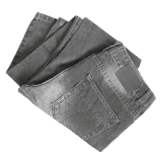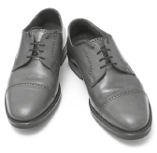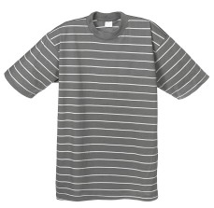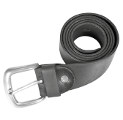

B. Tick (✓) TRUE or FALSE.
TRUE FALSE
1. Sheldon is from the USA.

2. Melissa has got brown hair, like her mother.

3. Sheldon and his brother Georgie are in high school.

4. Sheldon’s favourite food is sausages with rice.

C. Answer the questions about the text. Give complete answers.
1. What type of house has Sheldon got?
2. Are Sheldon and Georgie twins?
3. What is their father’s job?
4. How does Sheldon go to school?
5. Why does Sheldon do his homework very quickly?
D. Label the pictures with the daily activities from the box.
go to bed | have classes | have breakfast | have dinner | do his homework

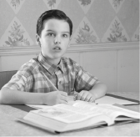 |  | 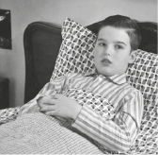 | 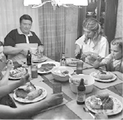 | 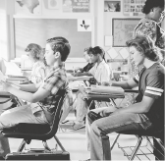
1.________________  ________________ | 2.________________  ________________ | 3.________________  ________________ | 4.________________  ________________ | 5.________________  ________________
E. Label the means of transport.
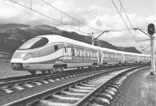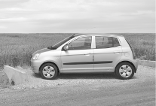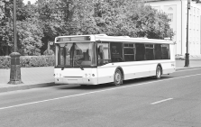
1
2
3
4
1._________________
2._________________
3._________________
4._________________
5._________________
t
p
c
m
b
5
F. Look at the picture and write the names of the characters to complete the sentences.
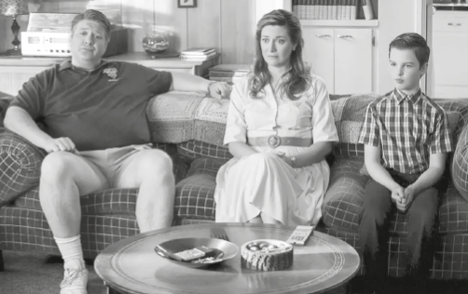
1. ________________ is fat.
George
Mary
Sheldon
2. _____________ and ____________ are slim.
3. _______________________________ is short.
4. ________________ has got long hair.
5. ________________ is wearing shorts.
6. ________________ is wearing a dress.
7. ________________ is wearing trousers.
8. ________________ is wearing trainers.

G. Complete the text with the present simple form of the verbs in brackets.

Hi! I’m Raegan Revord and I ¹________________ (play) Missy in the series
Young Sheldon. My parents and I ²________________ (live) in California.
I ³________________ (have) a normal life. Every day I ⁴________________
(go) to school by car with my best friend because her mother
⁵________________ (work) next to our school.
I ⁶_______________ (love) going to school, but I ⁷_______________ (not like)
history. I ⁸_______________________ (prefer) maths – it’s my favourite
subject! And the teacher ⁹________________ (teach) really well!
What about you? ¹⁰_________________ you _________________ (like) going
to school?
H. Complete the sentences with the present continuous form of the verbs in brackets.
are listening
• We _______________________ (listen) to music now.
1. At the moment, I ________________________________ (watch) TV.
2. Georgie __________________ (not do) his homework. He __________________ (listen) to music.
3. Missy and I ________________________________ (play) board games.
4. “__________________ they __________________ (ride) their bikes?” “Yes, they __________________.”
I. Write the past simple form of the verbs (regular and irregular).
1. play 4. buy
2. watch 5. go
3. study 6. do

J. Circle the correct reflexive pronoun to compete the sentences.
1. I can do it myself / yourself. I don’t need help.
2. Missy loves looking at themselves / herself in the mirror.
3. They are enjoying themselves / himself at the party.
4. Can you do that by yourself / itself?
5. Peter is doing the exercise by ourselves / himself.
K. Write a short text (25-30 words) about your daily routine.

