Progress Test
Name No.: _____ Class: _______ Date: ____/ ____/ ____
Mark: ________________ Teacher ____________________________ Enc. Educação
1A
I – Reading
Read the texts.
Teenagers with special features
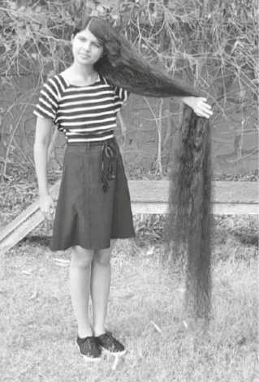
5  10  15 | Hi! My name is Nilanshi Patel, I’m 16 years old and I’m from  India, so I’m Indian. People call me the “real-life Rapunzel” and  it’s very easy to understand why: I’m the teenager with the  longest hair in the world. My hair is two meters long!  Every day I wake up at 7:30 a.m. and then I have a  shower, but I only wash my hair once a week. On that day,  I wake up really early because my hair takes thirty minutes to dry  and it takes one hour to comb. But that’s not a problem because  my mother always helps me. I usually have a long braid¹ and I  really like it! On the other days I have a perfectly normal routine  and my hair doesn’t bother² me at all. I go to school, hang out  with my friends and I do sports. My favorite sport is table  tennis, I love it! I feel good about myself. I am medium height  and slim. I’ve got a big mouth, brown eyes. But my favorite  part of my body is, of course, my beautiful long hair!

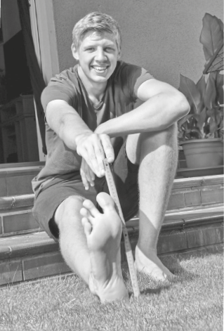

5  10 | Hello! My name is Lars Motza and I’m from Germany.  I’m 16 years old and I’m the teenager with the largest  feet in the world! Can you guess what my shoe size is?  It’s size 57! So, as you can imagine, it’s really hard to  find shoes my size and that’s a problem for me… I can’t  wear common trainers like my friends – all my shoes are  custom-made³. My dream is to have cool trainers or a nice  pair of hiking boots for my tours with the scouts.  Having big feet is common in my family. My father,  Frank, is size 50 and my mother is size 43.  If you also have an uncommon feature, take my advice:  no matter what others say, stay true to yourself and always  think positively.

Vocabulary: ¹ braid = trança; ² bother = incomoda; ³ custom-made = feitos à medida

A. Complete the table with information from the texts.
Name | Nilanshi | Lars
Surname | 1. | 6.
Age | 2. | 7.
Country | 3. | 8.
Nationality | 4. | 9.
Special feature | 5. in the world | 10. in the world
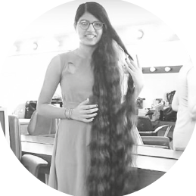
B. Complete the sentences with Nilanshi or Lars, according to the texts.
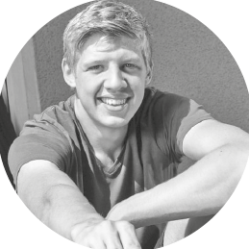
1. ________________’s special feature is a problem.
2. ________________ is a scout.
3. ________________ likes table tennis.
4. ________________ thinks it’s important to think positively.
5. People compare ________________ to Rapunzel.
C. Read the sentences and tick (✓) TRUE or FALSE.
TRUE FALSE
1. Nilanshi’s hair is 12 meters long.

2. Nilanshi wakes up at half past seven.

3. Nilanshi’s thinks her hair is beautiful.

4. Lars’s parents have got small feet.

5. Lars thinks people with special features should stay true to themselves.

D. Answer the questions about the text. Give complete answers.
1. How often does Nilanshi wash her hair?

2. Is Nilanshi’s hair a problem for her?

3. What does Nilanshi look like?

4. Why is it difficult for Lars to find shoes?

5. What is Lars’s dream?

II – Language
E. Complete the sentences with the family members from the boxes. There are two extra words.
1. My parents’ daughter is my
brother
uncle
cousin
sister
father
aunt
grandmother
2. My father’s mother is my
3. My mother’s sister is my
4. My uncle’s son is my
5. My father’s brother is my
F. Look at the pictures and match them with the texts. Write numbers 1-4.
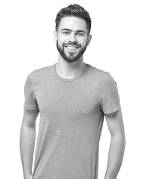 | 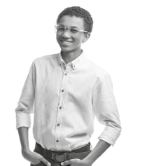 | 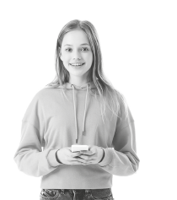 | 
1. I’m tall and slim. I’ve got short curly hair. My skin is dark and I wear glasses.
2. I’m short and thin. I’ve got long straight hair and an oval face.
3. I’m tall and thin. I’ve got short hair and a beard.
4. I’m medium height and I’m bald. I wear glasses and I have a big smile.
G. Look at the pictures and complete the sentences with the correct morning activity or the time.
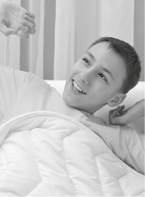  7:15 | 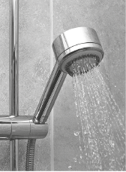  7:30 | 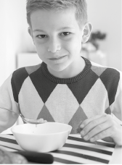  8:00 | 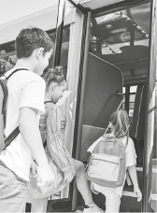  8:20 |   8:30
1. He ________________________________ at a quarter past seven.
2. At half past seven he ________________________________.
3. At eight o’clock a.m., he ________________________________.
4. At ________________________________, he goes to school by bus.
5. He has classes at ________________________________.

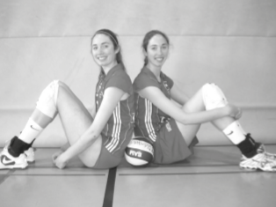

H. Circle the correct personal pronoun or possessive determiner to complete the sentences.
Claire and Ann Recht are the tallest twin sisters in the world.
¹ They / We are from the USA and they are 2 metres 01 tall. ² Her / Their
favourite sport is volleyball, they play ³ him / it really well! They have
got a brother and ⁴ she / he is even taller: 2 metres 10!
I. Complete the sentences with the verbs to be or have got.
1. Hi, my name is Claire and I _______________  very tall! | 4. She __________________ long straight hair, just  like me.
2. I __________ a twin sister. Her name is Ann. | 5. We __________________ the tallest twins in the  world.
3. Ann __________________ also very tall. | 5. We __________________ the tallest twins in the  world.
J. Complete the sentences with the possessive pronouns from the boxes. There are two extra words.
1. “Is this book yours?” “No, it belongs to Jane – it’s _________________.”
ours
his
theirs
hers
yours
mine
2. This isn’t my car – it belongs to my father. The car is _________________.
3. This is John and Peter’s house. The house is _________________.
4. “Is this your ball, Michael?” “Yes, it’s _________________.”
K. Complete the sentences with the present simple of the verbs in brackets.
1. He always ____________ (brush) his teeth. 3. My friends ____________ (go) to school by bus.
2. She ____________ (not wash) her hair every day. 4. Mark and I ____________ (not walk) to school.
L. Look at the pictures. Write questions and answers using the present simple.
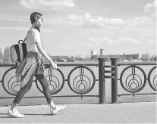  1 | 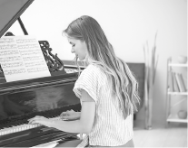  2 |   3 | 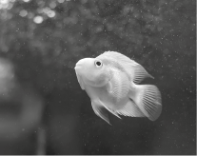  4
• “__________________________ (go) to school by car?” “ __________________________.”
No, she doesn't
Does she go
1. “__________________________ (play) the piano?” “____________ , __________________________.”
2. “__________________________ (drink) coffee?” “____________ , __________________________.”
3. “__________________________ (swim)?” “____________ , __________________________.”
M. Put the words in order to make correct sentences.
1. hardly / my sister / watches / ever / TV / .
2. is / at / home / Claire / always / .
3. Barbara / her / bike / rides / sometimes / .

III – Writing
N. Choose ONE topic (1 or 2) and write a short text (35-50 words) about it.
1. Describe yourself. Don’t forget to mention:
- personal ID (name, country, nationality, family, free time activities…);
- physical appearance (height, weight, hair, eyes, special features – if you have any – personality…).
2. Describe your daily routine. Don’t forget to mention:
- what you do in the morning;
- what you do in the afternoon;
- what you do in the evening.

Topic ________________________________

