Progress Test
Name No.: _____ Class: _______ Date: ____/ ____/ ____
Mark: ________________ Teacher ____________________________ Enc. Educação
1B
I – Reading
Read the texts.
Teenagers with special features
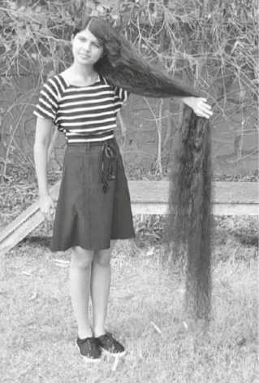
5  10  15 | Hi! My name is Nilanshi Patel, I’m 16 years old and I’m from  India, so I’m Indian. People call me the “real-life Rapunzel” and  it’s very easy to understand why: I’m the teenager with the  longest hair in the world. My hair is two metres long!  Every day I wake up at 7:30 a.m. and then I have a  shower, but I only wash my hair once a week. On that day,  I wake up really early because my hair takes thirty minutes to dry  and it takes one hour to comb. But that’s not a problem because  my mother always helps me. I usually have a long braid¹ and I  really like it! On the other days I have a perfectly normal routine  and my hair doesn’t bother² me at all. I go to school, hang out  with my friends and I do sports. My favourite sport is table  tennis, I love it! I feel good about myself. I am medium height  and slim. I’ve got a big mouth, brown eyes. But my favourite  part of my body is, of course, my beautiful long hair!

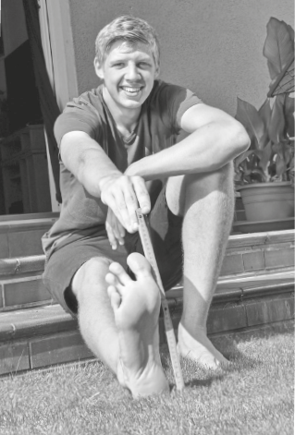

5  10 | Hello! My name is Lars Motza and I’m from Germany,  so I’m German. I’m 16 years old and I’m the teenager  with the largest feet in the world! Can you guess what my  shoe size is? It’s size 57! So, as you can imagine, it’s really  hard to find shoes my size and that’s a problem for me… I  can’t wear common trainers like my friends – all my shoes  are custom-made³. My dream is to have cool trainers or a  nice pair of hiking boots⁴ for my tours with the scouts.  Having big feet is common in my family. My father,  Frank, is size 50 and my mother is size 43.  If you also have an uncommon feature, take my advice:  no matter what others say, stay true to yourself and always  think positively.

Vocabulary: ¹ braid = trança; ² bother = incomoda; ³ custom-made = feitos à medida
⁴ hiking boots = botas de caminhada

A. Complete the table with the underlined information from the texts.
Name | Nilanshi | Lars
Surname | 1. | 6.
Age | 2. | 7.
Country | 3. | 8.
Nationality | 4. | 9.
Special feature | 5. in the world | 10. in the world
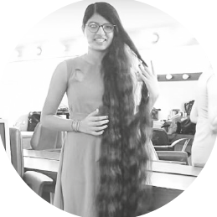
B. Complete the sentences with Nilanshi or Lars, according to the texts.
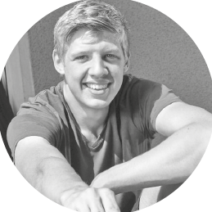
1. ________________’s special feature is a problem.
2. ________________ is a scout.
3. ________________ likes table tennis.
4. ________________ thinks it’s important to think positively.
5. People compare ________________ to Rapunzel.
C. Read the sentences and tick (✓) TRUE or FALSE.
TRUE FALSE
1. Nilanshi’s hair is 12 metres long.

2. Nilanshi wakes up at 7:30.

3. Nilanshi’s has got brown eyes.

4. Lars’s parents have got small feet.

5. Lars’s advice is “always think positively”.

D. Answer the questions about the text. Use the words/expressions from the box.
1. How often does Nilanshi wash her hair?
Nilanshi washes her hair
.
cool trainers
once a week
it isn’t
medium height
and slim
feet
2. Is Nilanshi’s hair a problem for her?
No,
.
3. What does Nilanshi look like?
She is she has got a big mouth
and brown eyes
.
4. Why is it difficult for Lars to find shoes?
It's hard to find shoes because he has got really large
.
5. What is Lars’s dream?
His dream is to have or a nice pair of hiking boots
for his tours with the scouts
.

II – Language
E. Complete the sentences with the family members from the boxes.
1. My parents’ daughter is my
uncle
cousin
sister
aunt
grandmother
2. My father’s mother is my
3. My mother’s sister is my
4. My uncle’s son is my
5. My father’s brother is my
F. Look at the pictures and match them with the texts. Write numbers 1-4.
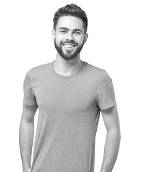 | 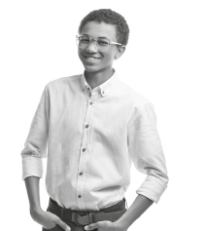 | 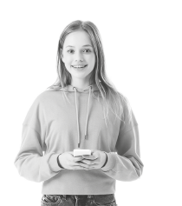 | 
1. I’m Tom. I’ve got short curly hair. My skin is dark and I wear glasses.
2. I’m Lucy. I’ve got long straight hair and an oval face.
3. I’m Mark. I’ve got short hair and a beard.
4. I’m Peter. I’m bald, I wear glasses and I have a big smile.
G. Look at the pictures and match them with the sentences. Write the letters a-e.
  a)  7:15 | 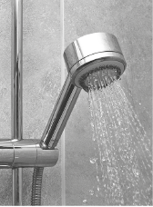  b)  7:30 | 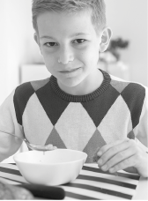  c)  8:00 | 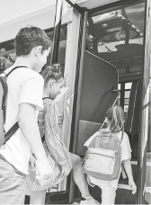  d)  8:20 | e)  8:30
1. At twenty past eight, he goes to school by bus.

2. He wakes up at a quarter past seven.

3. At eight o’clock a.m., he has breakfast.

4. He has classes at half past eight.

5. At half past seven he has a shower.

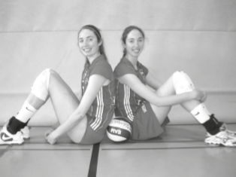

H. Circle the correct personal pronoun or possessive determiner to complete the sentences.
Claire and Ann Recht are the tallest twin sisters in the world.
¹ They / We are from the USA and they are 2 metres 01 tall. ² Her / Their
favourite sport is volleyball, they play ³ him / it really well! They have
got a brother and ⁴ he / you is even taller: 2 metres 10!
I. Complete the sentences with am, is, are, have got or has got.
1. Hi, my name is Claire and I _______________  very tall! | 4. She __________________ long straight hair, just  like me.
2. I __________ a twin sister. Her name is Ann. | 5. We __________________ the tallest twins in the  world.
3. Ann __________________ also very tall. | 5. We __________________ the tallest twins in the  world.
J. Complete the sentences with the possessive pronouns from the box.
mine
his
hers
theirs
1. “Is this book yours?” “No, it belongs to Jane – it’s _________________.”
2. This isn’t my car – it belongs to my father. The car is _________________.
3. This is John and Peter’s house. The house is _________________.
4. “Is this your ball, Michael?” “Yes, it’s _________________.”
K. Circle the correct present simple forms and complete the sentences.
1. He always brush / brushes his teeth. 3. My friends goes / go to school by bus.
2. She doesn’t wash / don’t wash her hair every day. 4. Mark and I don’t walk / doesn’t walk to school.
L. Look at the pictures. Write questions and answers using the present simple.
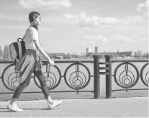  • | 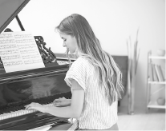  1 |   2 | 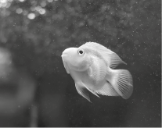  3
• “____________ to school by car?” “____________ , he _________________.”
doesn't
No
Does
1. “______________________ she play the piano?” “___________ , she________________________.”
2. “______________________ they drink coffee?” “___________ , they________________________.”
3. “______________________ it swim?” “___________ , it________________________.”
M. Put the words in order to make correct sentences.
1. hardly ever / my sister / watches TV / .
2. is / at home / Claire / always / .
3. Barbara / rides her bike / sometimes / .

III – Writing
N. Describe yourself. Write a short text (35-50 words) and don’t forget to mention personal ID and physical appearance. You may answer the questions below and use some words from the vocabulary box.
- What’s your name? / How old are you? / What nationality are you? / Who do you live with? / What are your favourite free time activities? / …
- What do you look like? (height, weight) / What colour are your eyes? / What is your hair like? /…
- Nationalities: Portuguese / Brazilian / Chinese / Russian / ...
- Family: father / mother / grandparents / brother / sister / cousin / ...
- Free time activities: watching TV / listening to music / surfing the net / ...
- Physical description: tall / short / medium height / slim / fat / thin / brown / black / green / short / long / curly / straight / blonde / beautiful / ugly / ...
Vocabulary box
Hi! My name is

