Progress Test
Name No.: _____ Class: _______ Date: ____/ ____/ ____
Mark: ________________ Teacher ____________________________ Enc. Educação
1C
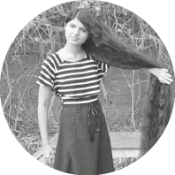
A. Read the texts and complete the table with the underlined words from the text.
Teenagers with special features

Hi! My name is Nilanshi and my surname is Patel, I’m 16 years old and
I’m from India, so I’m Indian. My friends call me “Rapunzel” because my hair is very special. It’s the longest hair in the world: it’s two metres long!
Hello! My name is Lars and my surname is Motza and I’m from Germany,
so I’m German. I’m 16 years old and I have special feet because
they are the largest in the world! My shoe size is 57!
Name | Nilanshi | 1.
Surname | Patel | 2.
Age | 16 years old | 3.
Country | India | 4.
Nationality | Indian | 5.
Special feature | hair | 6.
B. Look at the picture and complete the sentences with the family members from the box.

Sam
Andy
Karen
Hi! My name is Tom and this is my family. Andy is
my ¹______________ and Sam is my ²______________. Karen is
my ³________________ and John is my little ⁴________________.
John
Tom
brother | mother | father | grandfather

C. Look at the picture and circle the correct option to complete the sentences.

1. She is fat / slim.
2. She has got long / short hair.
3. She has got straight / curly hair.
4. She has got black / blonde hair.
5. She has got glasses / a beard.
6. She has got dark / light skin.

D. Look at the pictures and match them with the daily activities. Write numbers 1-5.
 | 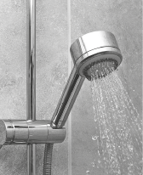 | 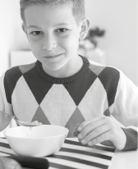 |  | 
1. have a shower | 2. have breakfast | 3. wake up | 4. have classes | 5. go to school

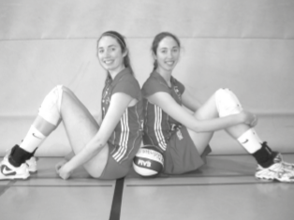
H. Circle the correct personal pronoun or possessive determiner to complete the sentences.
Claire and Ann Recht are the tallest twin sisters in the world.
¹ They / We are 2 metres 01 tall. ² Her / Their favourite sport is
volleyball, they play ³ him / it really well! They have got a brother and
⁴ he / you is 2 metres 10!
F. Circle the correct form ̶ to be or have got.
1. Hi, my name is Claire and I am / have got very tall!
2. I am / have got a twin sister, her name is Ann.
3. Ann is / has got also very tall.
4. She is / has got long straight hair.
5. We are / have got the tallest twins in the world.
G. Circle the correct possessive pronouns to complete the sentences.
1. “Is this book yours?” “No, it belongs to Jane. It’s theirs / hers.”
2. This isn’t my car, it belongs to my father. The car is his / mine.
3. This is John and Peter’s house. The house is ours / theirs.
4. “Is this your ball, Michael?” “Yes, it’s theirs / mine.”
H. Tick (✓) the correct sentences.
1. When he wakes up, he always brushes his teeth.
My name is Ciara. I’m 12
years old. I’m from Ireland.
I’m Irish.

2. She wash her hair every day.

3. All my friends go to school by bus.

4. My brother always study in his bedroom.

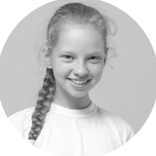
I. Look at the example and answer the questions about YOU.
My
1. What’s your name?
2. How old are you?
3. Where are you from?
4. What nationality are you?

