Progress Test
Name No.: _____ Class: _______ Date: ____/ ____/ ____
Mark: ________________ Teacher ____________________________ Enc. Educação
2A
I – Reading
Read the text.
2
4
3
1
 | A house for car lovers
5  10  15  20 | 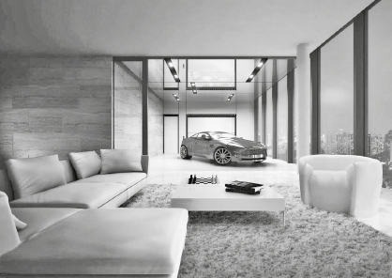  My name is Frank and I live in a big flat with my  parents and my two sisters. Our flat is very big. There  are three bedrooms (my sisters share a bedroom),  four bathrooms, a kitchen, a dining room, a living  room, a study and a laundry room.  My favourite room of the house is definitely the  living room because it’s a living room and a garage at  the same time! We live in a big city, but we don’t have  to worry about parking because we can park our car  in the living room! There is a special elevator to bring  the car inside, it’s really cool! My father loves his car, so this is his favourite part of the house too. But  there are other nice things in our living room. There are giant windows, so we can enjoy the amazing  view over the city and at night it’s even more beautiful! There is a big white sofa with fluffy cushions  where we can relax and watch some films in the evening.  My parents’ bedroom is also really cool! They have a private bathroom with a big bath and glass  walls! There is a big, comfortable bed with some pillows and a lamp above the bedside table. There is  also a nice carpet on the floor.  But there’s a room in my house that I don’t like. It’s the laundry room because I only go there to do  chores. My sisters and I always help around the house. I usually fold the laundry in the laundry room  and tidy my bedroom. My sisters tidy their bedroom as well and they do the washing up, but at the  moment they are setting the table and my parents are cooking because it’s dinner time!
A. Tick (✓) the appropriate title for each paragraph.
Paragraph 1
a) Furniture | b) The special bedroom | c) Rooms of the house
Paragraph 2
a) Favourite room | b) Private bathroom | c) The laundry room
Paragraph 3
a) The living room | b) The bedroom | c) Parts of the house
Paragraph 4
a) Relax in the evening | b) Type of house | c) Household chores

B. Which is Frank’s parents’ bedroom? Tick (✓).
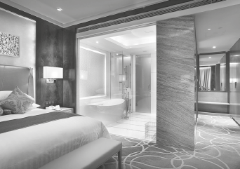
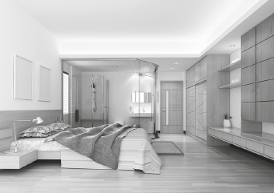
1

3

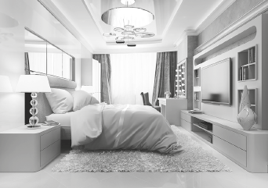
2

C. These sentences are all wrong. Correct the underlined information.
1. Frank lives in a small detached house.

2. The living room is Frank and his mother’s favourite part of the house.

3. They can enjoy the view over the city through the glass walls.

4. The lamp is in front of the bedside table.

5. Frank folds the laundry in the bedroom.

D. Answer the questions about the text. Give complete answers.
1. Is there a study in Frank’s house?

2. How do they bring the car into the living room?

3. Where do they usually watch films in the evening?

4. Does Frank like the laundry room? Why/Why not?

5. What are Frank’s sisters and parents doing at the moment?

II – Language
E. Label the pictures with the household chores from the box. There are two extra chores.
do the ironing | vacuum the floor | mop the floor
cut the grass | clear the table | do the washing up

 |  | 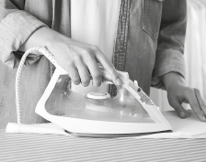 | 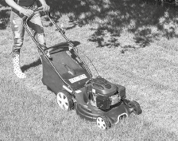
1.________________________ | 2.________________________ | 3.________________________ | 4.________________________
F. Label the rooms of the house or the furniture.
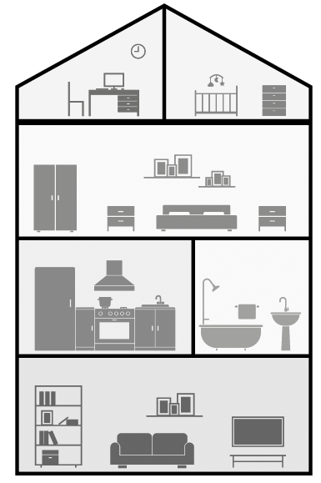
1._________________________________
2._________________________________
3._________________________________
4._________________________________
5._________________________________
6._________________________________
5
6
1
2
3
4
G. Complete the sentences with the present continuous form of the verbs in brackets.
is studying
• Jack ________________________ (study) for the English test.
1. At the moment Jack’s father ________________________ (park) his car in the living room.
2. His sisters ________________________ (have) dinner in the kitchen now.
3. ________________________ (Jack/do) his homework in the bedroom?
4. Jack and his sister ________________________ (not clear) the table at the moment.
5. Look! I ________________________ (wave) at you! Can you see me?
H. Complete the text with the present simple or present continuous of the verbs in brackets.
Today is Saturday. Jack and his family usually ¹_____________________ (do) household chores, but
now they ²_____________________ (not clean) the house. Jack’s father ³_____________________ (read)
a book and their sisters ⁴_______________________ (listen) to music in their bedroom. Jack
often ⁵_____________________ (fold) the laundry on Saturdays, but at the moment he
⁶_____________________ (play) with his dog. John’s mother rarely ⁷_____________________ (relax)
on Saturdays, but now she ⁸_____________________ (watch) a film in the living room. Today
⁹_____________________ (be) a national holiday and they always ¹⁰_____________________ (take)
holidays very seriously!

I. Circle the correct object pronouns to complete the sentences.
1. Look, aren’t they your friends? Invite her / them to come to our party!
2. I have a sister. I always have lunch with her / it.
3. That’s my English teacher. I really like us / him.
4. John and I are going to the cinema. Come with you / us.
5. It’s your birthday! Happy birthday to me / you!
J. Complete the text with the present simple or present continuous of the verbs in brackets.
under | on | between | in | opposite

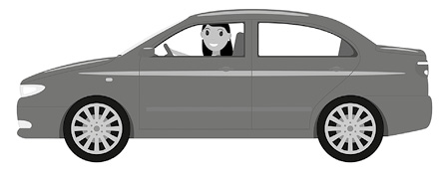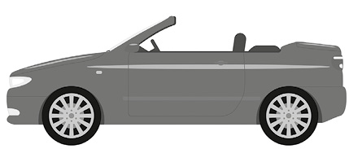
A
B

1. Car A is ___________________ car B.
2. The girl is ___________________ car B. | 4. The car keys are ___________________ car B.
3. The cat is ___________________ car A. | 5. The ball is ___________________ car A and car B.
K. Match the two halves and write new words.
1. book a) scraper 1. ____________________________

2. arm b) washer 2. ____________________________

3. sky c) case 3. ____________________________

4. dish d) room 4. ____________________________

5. bed e) chair 5. ____________________________

III – Writing
L. This is Frank’s bedroom. Look at the picture and describe it (35-50 words).
