Progress Test
Name No.: _____ Class: _______ Date: ____/ ____/ ____
Mark: ________________ Teacher ____________________________ Enc. Educação
2B
I – Reading
Read the text.
2
4
3
1
 | A house for car lovers
5  10  15  20 | 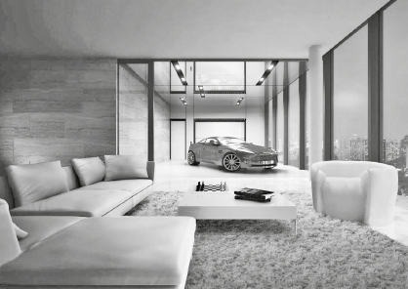  My name is Frank and I live in a big flat with my  parents and my two sisters. Our flat is very big. There  are three bedrooms (my sisters share a bedroom),  four bathrooms, a kitchen, a dining room, a living  room, a study and a laundry room.  My favourite room of the house is definitely the  living room because it’s a living room and a garage at  the same time! We live in a big city, but we don’t have  to worry about parking because we can park our car  in the living room! There is a special elevator to bring  the car inside, it’s really cool! My father loves his car, so this is his favourite part of the house too. But  there are other nice things in our living room. There are giant windows, so we can enjoy the amazing  view over the city and at night it’s even more beautiful! There is a big white sofa with fluffy cushions  where we can relax and watch some films in the evening.  My parents’ bedroom is also really cool! They have a private bathroom with a big bath and glass  walls! There is a big, comfortable bed with some pillows and a lamp above the bedside table. There is  also a nice carpet on the floor.  But there’s a room in my house that I don’t like. It’s the laundry room because I only go there to do  chores. My sisters and I always help around the house. I usually fold the laundry in the laundry room  and tidy my bedroom. My sisters tidy their bedroom as well and they do the washing up, but at the  moment they are setting the table and my parents are cooking because it’s dinner time!
A. Tick (✓) the appropriate title for each paragraph.
Paragraph 1
a) Rooms of the house | b) The special bedroom
Paragraph 2
a) Favourite room | b) Private bathroom
Paragraph 3
a) The living room | b) The bedroom
Paragraph 4
a) Relax in the evening | b) Household chores

B. Which is Frank’s parents’ bedroom? Tick (✓).
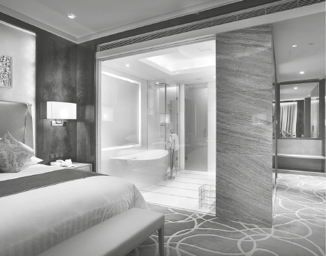  1 | 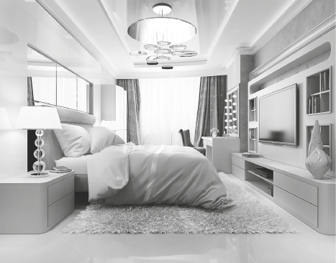  2
C. These sentences are all wrong. Correct the underlined information.
1. Frank lives in a small flat.

2. The living room is Frank and his mother’s favourite part of the house.

3. They can enjoy the view over the city through the giant wall.

4. The lamp is in front of the bedside table.

5. Frank folds the laundry in the bedroom.

D. Read the questions and complete the answers according to the text.
1. Is there a study in Frank’s house? Yes or No? (paragraph 1)
.
2. How do they bring the car into the living room? (paragraph 2)
There is a to bring the car inside.

3. Where do they usually watch films in the evening? (paragraph 2)
They usually watch films in the
.
4. Does Frank like the laundry room? Why/Why not? (paragraph 4)
because he only goes there to do
.
5. What are Frank’s sisters and parents doing at the moment? (paragraph 4)
Frank's sisters are and his parents are
.

II – Language
E. Label the pictures with the household chores from the box.
do the ironing | mop the floor | cut the grass | do the washing up

 |  |  | 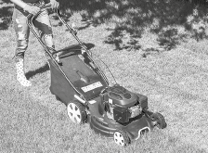
1.________________________ | 2.________________________ | 3.________________________ | 4.________________________
F. Unscramble the words to label the rooms of the house or the furniture.
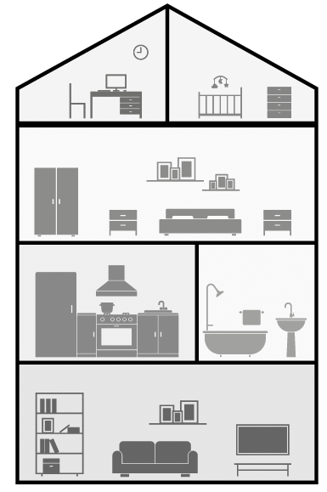
1. RODOMBE
2. HEKICNT
3. OKCAOBSE
4. CSHET of drawers
5. OMATBOHR
6. FSAO
1
5
4
6
2
3
G. Complete the sentences with the -ing form of the verbs in brackets.
studying
• Jack is ________________________ (study) for the English test.
1. At the moment Jack’s father is ________________________ (park) his car in the living room.
2. His sisters are ________________________ (have) dinner in the kitchen now.
3. Is Jack ________________________ (do) his homework in the bedroom?
4. Jack and his sister aren’t ________________________ (clear) the table at the moment.
5. Look! I am ________________________ (wave) at you! Can you see me?


H. Circle the correct verb forms to complete the text.
Today is Saturday. Jack and his family usually ¹ do / am doing household chores, but now
they ² don’t clean / aren’t cleaning the house. Jack’s father ³ reads / is reading a book and
their sisters ⁴ listen / are listening to music in their bedroom. Jack often ⁵ folds / is folding the
laundry on Saturdays, but at the moment he ⁶ plays / is playing with his dog. John’s mother rarely
⁷ relaxes / is relaxing on Saturdays, but now she ⁸ watches / is watching a film in the living room.
Today ⁹ is / is being a national holiday and they ¹⁰ take / are taking holidays very seriously!
I. Circle the correct object pronouns to complete the sentences.
1. Look, aren’t they your friends? Invite her / them to come to our party!
2. I have a sister. I always have lunch with her / it.
3. That’s my English teacher. I really like me / him.
4. John and I are going to the cinema. Come with us / it.
5. It’s your birthday! Happy birthday to me / you!
J. Look at the picture and write A or B according to the picture and the prepositions of place.
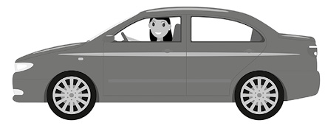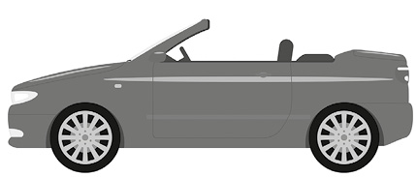
A
B
1. Car A is opposite car _________.
2. The girl is in car _________.
3. The cat is on car _________.
4. The car keys are under car _________.
5. The ball is between car _________ and car B.
K. Match the two halves and write new words.
1. book a) scraper 1. ____________________________

2. arm b) washer 2. ____________________________

3. sky c) case 3. ____________________________

4. dish d) room 4. ____________________________

5. bed e) chair 5. ____________________________

III – Writing
L. This is Frank’s bedroom. Look at the picture and describe it (35-50 words). You may use some words from the vocabulary box.
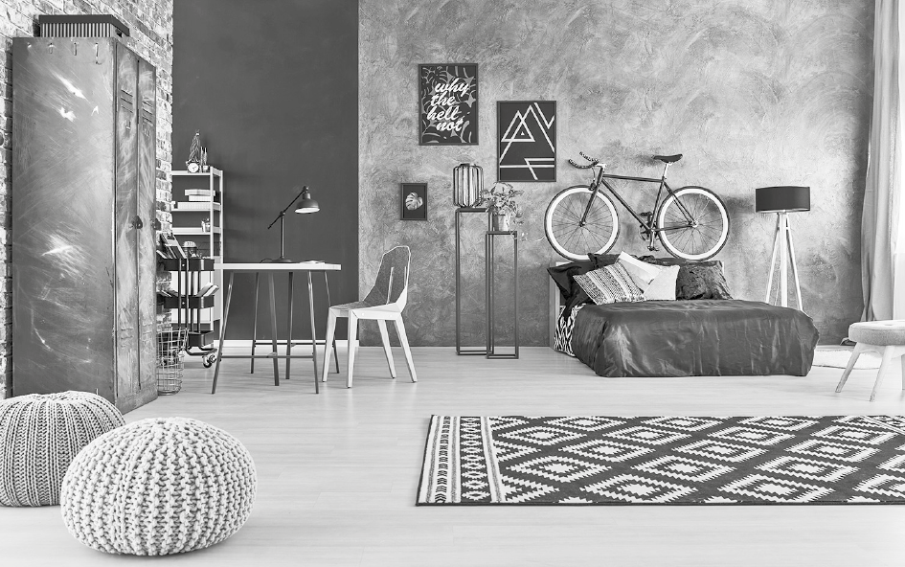
This is Frank's bedroom
- Verbs: there is, there are, is, has got…
- Prepositions of place: on, in, next to, opposite…
- Objects: bed, pillows, bicycle, paintings, desk, chair, rug, wardrobe, lamp…
- Adjetives: big, small, nice, ugly…
Vocabulary box

