Progress Test
Name No.: _____ Class: _______ Date: ____/ ____/ ____
Mark: ________________ Teacher ____________________________ Enc. Educação
2C
A. Read the text and tick (✓) the correct option to complete the sentences.
A house for car lovers
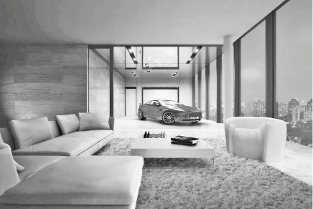
My name is Frank and I live in a big flat with my
parents and my two sisters.
Our flat is very big. There are three bedrooms,
four bathrooms, a kitchen, a dining room, a living
room, a study and a laundry room.
My favourite room of the house is the living room
because it’s a living room and a garage. We can
park our car in the living room! There is a special
elevator to bring the car inside. It’s really cool!
I love my house!
1. Frank lives in a | a) detached house. | b) flat. | c) castle.
2. Frank has got | a) two sisters. | b) a brother. | c) two brothers.
3. There are three | a) kitchens. | b) living rooms. | c) bedrooms.
4. There are four | a) bathrooms. | b) studies. | c) garages.
5. Frank’s favourite room is | a) his bedroom. | b) the kitchen. | c) the living room.
B. Complete the household chores with words from the box to label the pictures.
ironing | mop | grass | washing

 |  |  | 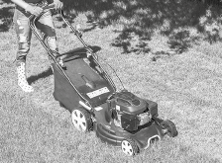
1. the floor. | 2. Do the | 3. Do the | 4. Cut the
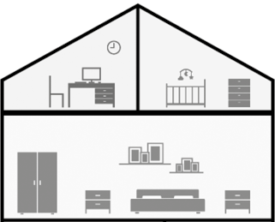
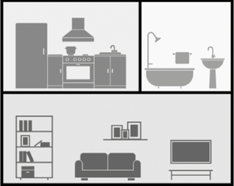
F. Write the missing vowels to label the rooms of the house.
1
2
3
4
5
1. ST __ D __
2. B __ DR __ __ M
3. K __ TCH __ N
4. B __ THR __ __ M
5. L __ V __ NG R __ __ M

D. Write the -ing form of the verbs.
studying
• study 3. play
1. read 4. clear
2. do 5. watch
E. Match the sentences with the correct verb tense. Draw lines.
1. I set the table every day. | • | • | a) Present continuous
2. I am setting the table at the moment. | • | • | b) Present simple

F. Circle the correct object pronoun.
  • I me / him | 2. he him / their | 4. we her / our
1. you her / you | 3. she our / her | 5. they them / me
G. Look at the picture and circle the correct prepositions of place.
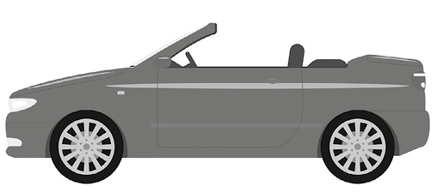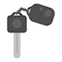
1
2
3
1. The cat is on / under the car.
2. The ball is under / next to the car.
3. The keys are in front of / between the car.
H. Match the two halves to create new words. Draw lines.
1. book | • | • | a) scraper
2. arm | • | • | b) chair
3. sky | • | • | c) case
I. Describe the Jack’s bedroom. Look at the picture and complete the sentences about it. Use the words from the box.
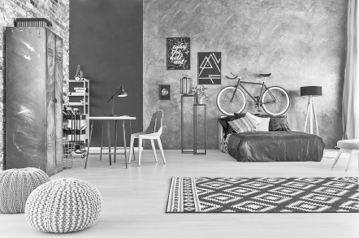
big small cool bed wardrobe desk
chair rug lamp paintings books pillows
1. Jack’s bedroom is .
2. There is a bicycle over the .
3. There is a ____________ and a .
4. There is a on the floor.
5. There are some .

