Progress Test
Name No.: _____ Class: _______ Date: ____/ ____/ ____
Mark: ________________ Teacher ____________________________ Enc. Educação
3A
I – Reading
Read the texts.
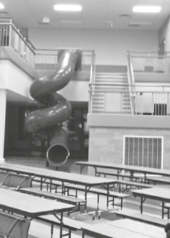
School favourites!
5 | I loved my primary school. It was a small school, with some classrooms,  a music room and a staffroom. It was a bit old, but comfortable. The  playground was great because it was very big with lots of trees and I loved  climbing trees! I was a good student and my favourite subject was English  (but now I prefer history…). My primary school was very special, but there  was something that was really, really great: the slide! Yes, there was a slide  inside the school! It was awesome and the fastest way to go downstairs!  Kelly, 15
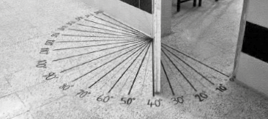
10  15 | When I was at school, my favourite subjects were physical education and  art, but I wasn’t very good at maths… However, I remember having a good  mark in a test that was about angles. And do you know why? Because there  was a special door in the maths room that helped the students to measure  the angles in degrees. With that help it was very easy to understand! My  school was great. There was a big playground where I usually played with  my friends. I was in the Basketball Club and I always participated in the  basketball tournament during Sports Day!  Harold, 27
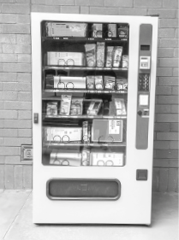
20 | I like my school! It’s very big and there are many classrooms! And there is a special  stationer’s. When I came to this school for the first time, I had to wait lots of time  in line¹ for the stationer’s and I hated it! But then they installed a vending machine²  with school supplies! Isn’t it genius? It’s much faster and it’s always “open”! If I  need a pencil, I just use the vending machine! No more waiting in lines!  Another great thing about this school is the school trips! My favourite school trip  was the one we made to the Natural History Museum, in London because I love  science, so it was very exciting to see the giant whale skeleton³!  Mindy, 11
Vocabulary: ¹ line = fila; ² vending machine = máquina automática de vendas; ³ skeleton = esqueleto
A. Label the pictures according to the texts. Write Kelly, Harold or Mindy.
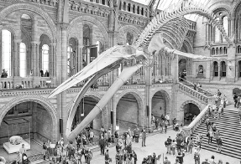 |  | 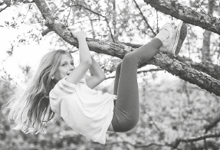
1.________________________________ | 2. ________________________________ | 3. ________________________________

B. Order the sentences according to Kelly’s text. Write numbers 1-7.
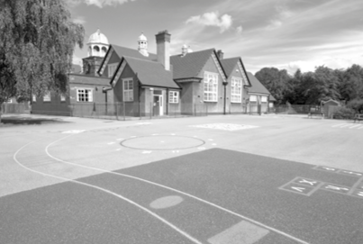
a) Kelly loved climbing trees.

b) It was small, but she loved her primary school.

c) There was a music room.

d) Kelly used the slide to go downstairs.

e) Kelly prefers history now.

f) There was a playground.

g) Kelly’s primary school was old.


C. Circle the correct option to complete the sentences.
1. Kelly’s favourite subject was history / English / music.
2. Harold remembers having a good mark in a maths / physical education / art test.
3. Harold usually played with his friends in the basketball field / maths room / playground.
4. At Kelly’s / Harold’s / Mindy’s school there was a basketball tournament during Sports Day.
5. Mindy hated waiting in line for the library / vending machine / stationer’s.
D. Answer the questions about Harold and Mindy. Give complete answers.
1. What were Harold’s favourite subjects?

2. Where was the special door in Harold’s school?

3. Was Harold in the Football Club?

4. What are the advantages of the vending machine at Mindy’s school?

5. Why was the visit to the museum Mindy’s favourite school trip?

II – Language
E. Label the pictures with the school subjects
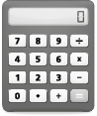 |  |  |  | 
1.__________________ | 2.__________________ | 3.__________________ | 4.__________________ | 5.__________________
F. Complete the sentences with the school facilities from the box.
library | sports field | classroom | stationer’s | canteen

1. It’s lunchtime. Let’s go to the ______________________ and have lunch together!
2. Oh, I forgot my jacket in the ____________________. Let me see if the English teacher is still there!
3. Let’s meet at the ______________________ after lunch to play basketball!
4. My notebook is full… I need to go to the ______________________ and buy a new one.
5. I need to go to the ______________________ to borrow a book for my Portuguese presentation.
G. Complete the sentences with the past simple of the verb to be.
1. My grandmother ______________________ the best student in her class.
2. Sarah ______________________ (not) at home yesterday.
3. Last week, John and Lucas ______________________ (not) at the cinema.
4. Where ______________________ you yesterday?
5. I ______________________ at school, as always!
H. Complete the sentences with the past simple of the regular verbs in brackets.
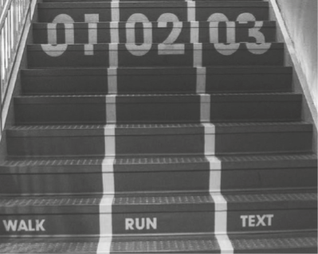
Last week my parents and I ¹______________________ (visit)
my brother at his university. It ²______________ (not rain),
so we ³___________________ (walk) in the campus. It’s very
big! Then we ⁴______________________ (help) my brother
clean his bedroom. I ⁵____________________ (discover) the
best stairs ever! They have three different ways, so
we never get stuck behind slow people! What a great
idea! I ⁶______________________ (enjoy) this visit a lot and
I ⁷____________________ (not want) to leave. I can’t wait to
go to university!

I. Fill in the table with the past simple form of the irregular verbs.
Infinitive | Past simple |  | Infinitive | Past simple
go | 1. |  | make | 4.
see | 2. |  | eat | 5.
put | 3. |  | swim | 6.
J. What did they do yesterday? Look at the pictures, then write questions and answers.
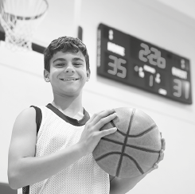
•
2
1
3
• Tom / play football
Did Tom play football No, he didn't. He played basketball
? .
1. Kate / drink water
? .
2. They / study
? .
3. Peter / read the newspaper
? .
K. Circle the correct connector to complete the sentences.
1. Tomorrow is school day. Because / Therefore, I need to go to bed early.
2. I studied a lot. However / So, I had a bad mark.
3. I really need to study and / because I have a test tomorrow.?

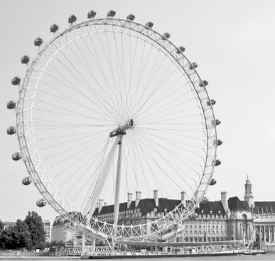
III – Writing
London Eye
L. Look at the pictures of a school trip to London. Imagine your school is near London and you went on this school trip. Write a short text about it (35-50 words). You can mention:
- means of transport used;
- who you went with;
- what you did in the morning;
- where you had lunch;
- what you did in the afternoon;
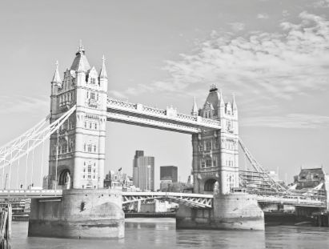
- your opinion about the school trip.
Tower Bridge
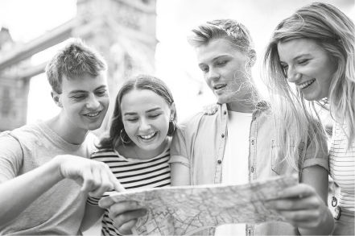
Sightseeing

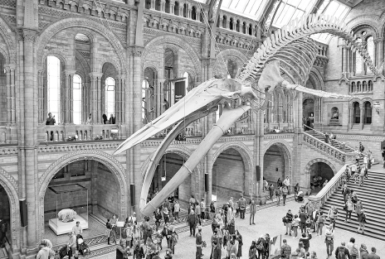
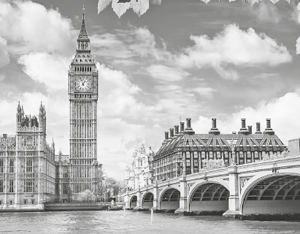
Natural History Museum
Big Ben

