Progress Test
Name No.: _____ Class: _______ Date: ____/ ____/ ____
Mark: ________________ Teacher ____________________________ Enc. Educação
3B
I – Reading
Read the texts.
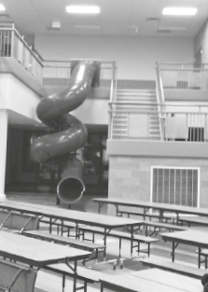
School favourites!
5 | I loved my primary school. It was a small school, with some classrooms,  a music room and a staffroom. It was a bit old, but comfortable. The  playground was great because it was very big with lots of trees and I loved  climbing trees! I was a good student and my favourite subject was English  (but now I prefer history…). My primary school was very special, but there  was something that was really, really great: the slide! Yes, there was a slide  inside the school! It was awesome and the fastest way to go downstairs!  Kelly, 15
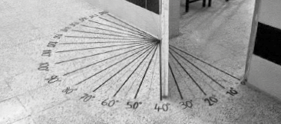
10  15 | When I was at school, my favourite subjects were physical education and  art, but I wasn’t very good at maths… However, I remember having a good  mark in a test that was about angles. And do you know why? Because there  was a special door in the maths room that helped the students to measure  the angles in degrees. With that help it was very easy to understand! My  school was great. There was a big playground where I usually played with  my friends. I was in the Basketball Club and I always participated in the  basketball tournament during Sports Day!  Harold, 27
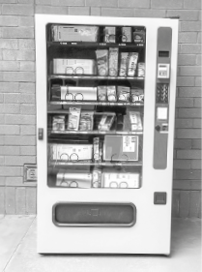
20 | I like my school! It’s very big and there are many classrooms! And there is a special  stationer’s. When I came to this school for the first time, I had to wait lots of time  in line¹ for the stationer’s and I hated it! But then they installed a vending machine²  with school supplies! Isn’t it genius? It’s much faster and it’s always “open”! If I  need a pencil, I just use the vending machine! No more waiting in lines!  Another great thing about this school is the school trips! My favourite school trip  was the one we made to the Natural History Museum, in London because I love  science, so it was very exciting to see the giant whale skeleton³!  Mindy, 11
Vocabulary: ¹ line = fila; ² vending machine = máquina automática de vendas; ³ skeleton = esqueleto
A. Look at the underlined expressions in the texts and circle the correct option to label the pictures.
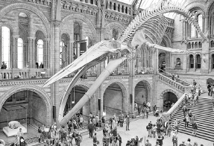 |  | 
1. Kelly / Harold / Mindy | 2. Kelly / Harold / Mindy | 2. Kelly / Harold / Mindy

B. Order the sentences according to Kelly’s text. Write numbers 1-7.
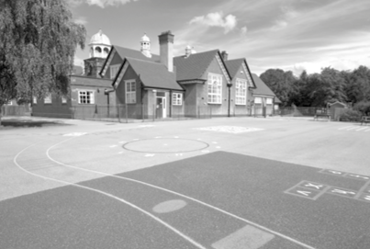
a) “I loved climbing trees.”

b) “It was a small school.”

c) “… a music room and a staffroom.”

d) “… the fastest way to go downstairs.”

e) “but now I prefer history.”

f) “The playground was great.”

g) “It was a bit old, but comfortable.”


C. Circle the correct option to complete the sentences.
1. Kelly’s favourite subject was history / English. (line 4)
2. Harold remembers having a good mark in a maths / art test. (lines 9-10)
3. Harold usually played with his friends in the basketball field / playground. (lines 13-14)
4. At Kelly’s / Harold’s school there was a basketball tournament during Sports Day. (lines 14-15)
5. Mindy hated waiting in line for the vending machine / stationer’s. (lines 17-18)
D. Read the questions and complete the answers according the text.
1. What were Harold’s favourite subjects?
Harold's favourite subjects were and
.
2. Where was the special door in Harold’s school?
It was in the
.
3. Was Harold in the Football Club? Yes or No?
.
4. What are the advantages of the vending machine at Mindy’s school?
It's much and it's always
.
5. Why was the visit to the museum Mindy’s favourite school trip?
The visit to the museum was Mindy's favourite school trip because it was very

.

II – Language
E. Label the pictures with the school subjects from the box.
PE | maths | art | geography | history

 |  |  |  | 
1.__________________ | 2.__________________ | 3.__________________ | 4.__________________ | 5.__________________
F. Complete the sentences with the school facilities.
 |  |  |  | 
library | sports field | canteen | stationer’s | classroom
1. It’s lunchtime. Let’s go to the ___________________ and have lunch together!
2. Oh, I forgot my jacket in the ___________________. Let me see if the English teacher is still there!
3. Let’s meet at the ___________________ after lunch to play basketball!
4. My notebook is full... I need to go to the ___________________ and buy a new notebook.
5. I need to go to the ___________________ to borrow a book for my Portuguese presentation.
G. Complete the sentences with was, were, wasn’t or weren’t.
1. My grandmother ___________________ the best student in her class.
2. Sarah ___________________ (not) at home yesterday.
3. Last week, John and Lucas ___________________ (not) at the cinema.
4. Where ___________________ you yesterday?
5. I ___________________ at school, as always!
H. Circle the correct option to complete the sentences with the past simple of the regular verbs.
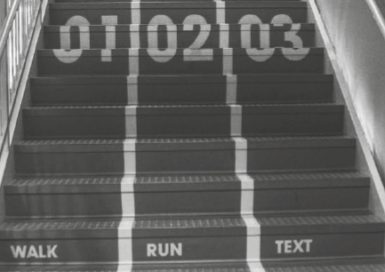
Last weekend my parents and I ¹ visited / visit
my brother at his university. It was really nice!
It ² didn’t rained / didn’t rain, so we ³ walked / walk in
the campus. It’s very big! Then we ⁴ helping / helped
my brother clean his bedroom. I ⁵ discovered / discover
the best stairs ever! They have three different ways,
so we never get stuck behind slow people! What
a great idea! I ⁶ enjoying / enjoyed this visit a lot and
I ⁷ didn’t wanted / didn’t want to leave. I can’t wait
to go to university!
I. Fill in the table with the past simple form of the irregular verbs from the box.
swam | ate | saw | went | made | put

Infinitive | Past simple |  | Infinitive | Past simple
go | 1. |  | make | 4.
see | 2. |  | eat | 5.
put | 3. |  | swim | 6.
J. What did they do yesterday? Look at the pictures and answer the questions.
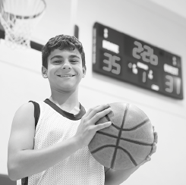
No, he didn't.
Tom
Kate
They
Peter
• Did Tom play football?
1. Did Kate drink water?
2. Did they study?
3. Did Peter read the newspaper?
K. Circle the correct connector to complete the sentences.
1. Tomorrow is school day. But / Therefore, I need to go to bed early.
2. I studied a lot. However / Because, I had a bad mark.
3. I really need to study and / because I have a test tomorrow.

III – Writing
L. Look at the pictures of a school trip to London. Write a short text about it (35-50 words). You may answer the questions below and use some words from the vocabulary box.
- bus / car / underground / taxi / plane / train
- friends / teachers / colleagues
- Natural History Museum / London Eye /
Tower Bridge / Big Ben / walk along the streets /
take selfies
- shopping centre / restaurant / picnic in the park
- great / interesting / boring / good
Vocabulary box
- Where did you go?
- What means of transport did you use?
- Who did you go with?
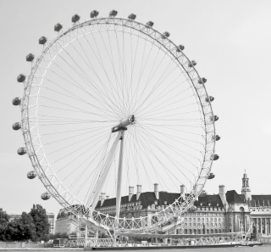
- What did you do in the morning?
London Eye
- Where did you have lunch?
- What did you do in the afternoon?
- What is your opinion about it?
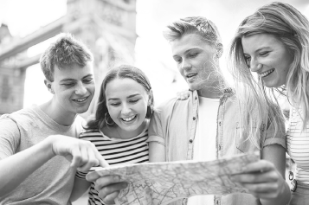
Sightseeing

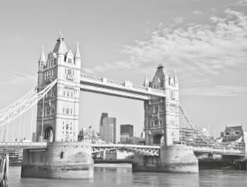
Tower Bridge

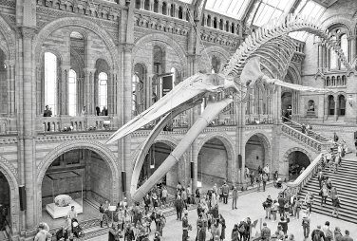
Natural History Museum
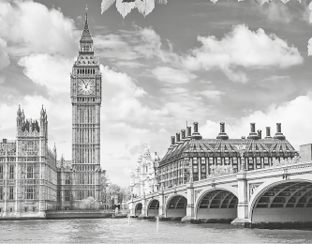
Big Ben

Last week, we went on a school trip to

