Progress Test
Name No.: _____ Class: _______ Date: ____/ ____/ ____
Mark: ________________ Teacher ____________________________ Enc. Educação
4B
I – Reading
Read the article.
 | Shop on the go
5  10  15  20 | 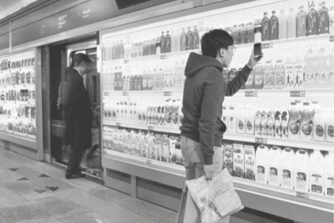  South Koreans work many hours a day, so the workers  are often too busy to go shopping for grocery at a  traditional store. The UK's giant supermarket, Tesco,  introduced "virtual stores", which are essentially  a display of products on walls of the underground  stations and bus stops. People scan the QR codes of the  products on display with their smartphones, and place  their orders as they wait for the train or bus.  The virtual stores are set up in public spaces, most  often in underground stations and bus stops with high  foot traffic¹. This is how the stores work:  - interested customers must download the Homeplus app into their smartphones;  - then they use their smartphones to scan the QR codes of the products they want to purchase. The  posters in the virtual stores are designed to look like the actual aisles and shelves of a regular Tesco  store, making the experience very user-friendly;  - the scanned products are stored in the customers' virtual shopping cart, and they pay online once  their order is completed. Homeplus reported that the majority of the orders are placed at 10 a.m.  and 4 p.m., when people are commuting² to and from work;  - customers schedule a time for home delivery. Same-day delivery is the norm, so that customers  can get their products by the time they get back home from work.  The virtual store was a huge success with commuters and there were over 900,000 app downloads in  less than one year, making the Homeplus app the most popular shopping app in South Korea.
 | https://www.businesstoday.in (abridged and adapted, accessed in December 2020)
Vocabulary: ¹ high foot traffic = muitas pessoas a andar a pé; ² commuting = a viajar

A. Complete the expressions to label the pictures. Circle the correct option.
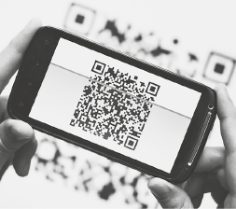
1
2
3
4
1. Scan / Write the QR codes. 3. Pay / Play online.
2. Wait for the bus / train. 4. Get back home / to school.

B. Match the words from the text with their definition. Write numbers 1-4.
1. display (line 5) a) Long, narrow spaces between the rows of shelves in a large shop.

2. aisles (line 14) b) People who regularly commute (travel) between work and home.

3. delivery (line 19) c) A collection of objects displayed for people to look at.

4. commuters (line 21) d) The act of delivering products to people's houses.

C. Three of these sentences are false. Tick (✓) them.
1. Tesco is a giant South Korea’s supermarket. (line 3)

2. Interested customers must download the Homeplus app. (line 12)

3. To buy the products, people use smartphones. (line 13)

4. The majority of orders are placed at 12 a.m. (lines 17-18)

5. The Homeplus app is the most popular gaming app in North Korea. (line 22)

D. Correct the false sentences from exercise C using sentences/expressions from the text.
________ –
________ –
________ –
E. Read the questions and complete the answers according the text.
1. Where are these virtual stores located? (lines 5-6)
They are located in underground and

2. What must customers do first to buy at these stores? (line 12)
First, they

3. Why are virtual stores user-friendly? (lines 13-15)
The stores are user-friendly because the posters in the virtual stores

4. Do the customers have a real shopping cart? Yes or No? (line 16)

II – Language
F. Label the pictures with the city places/features from the box.
park | crossroads | traffic lights | bus stop | bridge | traffic sign | skyscraper | tunnel

 |  |  | 
1.________________________ | 2.________________________ | 3.________________________ | 4.________________________
 |  |  | 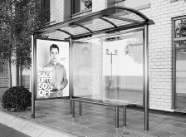
5.________________________ | 6.________________________ | 7.________________________ | 8.________________________
G. Write the missing words to complete the dialogue. Choose from the box.
shopping | museum | cinema | streets

A: Let’s go to the city!
B: OK! Can we go to the ¹___________________? There’s a new film I’d really love to watch…
A: Sure, but first we’ll go ²___________________ because I desperately need to buy new clothes!
And it’s good to walk along the ³___________________ and get some fresh air!
B: After that, can we visit a ⁴___________________? There are lots of new art exhibits and I love art!
H. Where can you buy these products? Write the names of the shops.
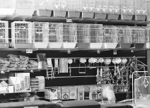
1
2
3
4
5
1. B __ K __ R’S 4. GR __ __ NGR __ C __ R’S
2. P __ T SH __ P 5. F __ SHM __ NG __ R’S
3. N __ __ S __ G __ NT’S

I. What were they doing yesterday? Use the words to write sentences in the past continuous.
Mark was cleaning the house
• Mark / clean / the house
1. Louise and Paul / shop / for clothes
2. the dog / chase / the cat
3. they / play / football
4. my grandfather / read / a book
5. my friends / study / for the test
6. her sister / buy / a magazine
J. Circle the correct option to complete the sentences.
I ¹ went / was going to the shoe shop yesterday to buy a new pair of shoes.
While I ² tried / was trying some shoes, the shop assistant ³ brought / was bringing other pairs
of shoes, so it was very difficult to choose! But I finally ⁴ made / was making my decision I
⁵ brought / was bringing some nice blue shoes!
At home, while I ⁶ opened / was opening the box, I had a big surprise… Do you know what I brought
from the shop? Two left feet shoes… Oh no!
K. Circle the correct modal verb to complete the sentences.
1. Sorry, I don’t understand. I mustn’t / can’t speak Portuguese.
2. May / Shouldn’t I use your bathroom, please?
3. You can’t / should buy that dress. It looks really good on you!
4. To use the virtual supermarket, you must / might install the app first.
5. Everyone is using the app. It might / shouldn’t be a success in the near future.
L. Complete the sentences with the imperative.
• When you drive, __________________ (pay) attention to the road.
1. To go to the library, __________________ (turn) right.
2. Please, don’t __________________ (use) the computer. It’s damaged.
3. Don’t __________________ (drive) so fast! It’s dangerous!
4. In the car, always __________________ (use) the seat belt!
M. Complete the sentences with the correct prepositions of movement from the box.
  1 |   2 |   3 | across  up  towards
1. She is going _____________________ the stairs.
2. She is running _____________________ her father.
3. They are walking _____________________ the street.
III – Writing
L. Do you like going shopping? Write a short text (35-50 words) about it. Answering the following questions may help you:
- Do you like shopping? Why?/Why not?
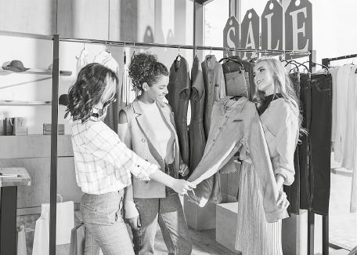
- Who do you usually go with?
- What are your favourite shops?
- What do you usually buy when you
go shopping?
- Do you usually shop online?
- What are the advantages/disadvantages
of shopping online?
- it’s fun / it’s boring
- my friends / my mother / my brother / my sister / ...
- clothes shops / sports shops / shoe shops / computer shop / ...
- clothes / footwear / accessories / gadgets / ...
- Yes, I do. / No, I don’t.
- It’s easier / it’s dangerous / it’s faster / ...
Vocabulary box
I like/don't like shopping because

