Progress Test
Name No.: _____ Class: _______ Date: ____/ ____/ ____
Mark: ________________ Teacher ____________________________ Enc. Educação
5A
I – Reading

Read the text.
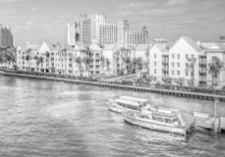
Around the World in 5 summer holiday destinations
 The Bahamas
In the Bahamas, you will get lost in the beautiful beaches. The Bahamas is the
place of Columbus’s first step when he discovered America. It has some of the
world’s most extraordinary beaches and awesome beach hotels.
Things to do: Snorkelling, going on boat tours  between Islands. | Travel tip: Do not leave your essential items on the  beach while swimming.

 Hawaii
It is really amazing and has got so much to offer to the tourists with some of
the most amazing islands and wonderful marine life. Hawaii is an attractive
destination for honeymooners¹, adventure lovers and families.
Things to do: Learn surfing in  Waikiki. | Travel tip: Going out to the mountains can be dangerous.  Try to be safe while taking photos!
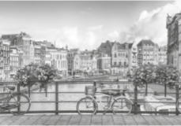
 Amsterdam
A lovely city where you can find beautiful cafés, houseboats and canals. It is a
popular destination in Europe for every traveller. You can find historical buildings
with amazing architecture.
Things to do: Cycling through the city; visiting  the Van Gogh Museum. | Travel tip: Do not walk in the cycle lanes.  Locals² will get really angry about it.

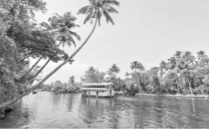
 Kerala, India
In Kerala you can find colonial landmarks³ and vibrant culture. Kerala’s beaches,
lakes, waterfalls, palaces and wildlife sanctuaries are major attractions.
Things to do: Staying in a houseboat. | Travel tip: If you enter any temple, you will have to take  off your shoes first.

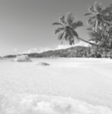
 The Seychelles
The Seychelles are a group of islands in the Indian Ocean. A clear blue sky, turquoise
water and calm beaches make this destination very popular. There are pink sand
beaches which are amazing.
Things to do: Scuba diving. | Travel tip: In order to protect the flora and fauna, don’t take  things from beaches, such as sea shells.
https://www.pahaditravelers.com (abridged and adapted, accessed in December 2020)
Vocabulary: ¹ honeymooners = casais em lua de mel; ² locals = locais; ³ landmarks = marcos/atrações

A. Where can you do these activities? Label the pictures with the places: the Bahamas, Hawaii, Amsterdam or the Seychelles.
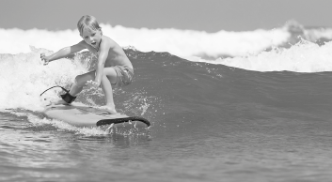 | 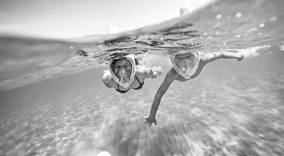
1.____________________________________ | 3.____________________________________
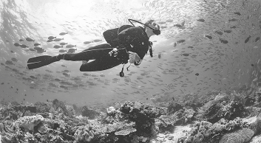 | 
2.____________________________________ | 4.____________________________________

B. Circle the correct option to complete the sentences according to the texts.
1. You must be careful with your essential items when you go swimming in
the Bahamas / the Seychelles.
2. Hawaii is the perfect destination for families / teenagers.
3. Be thankful / careful when you take photos in the mountains. It can be dangerous.
4. We can find houseboats in Amsterdam and the Bahamas / Kerala and Amsterdam.
5. Before entering a wildlife sanctuary / temple in India, people must take off their shoes.
6. In some beaches in the Seychelles the sand is turquoise / pink.
C. Answer the questions about the text. Give complete answers.
1. Who discovered America?

2. Where can we find awesome beach hotels?

3. What will Amsterdam locals get angry about?

4. What are the main attractions in Kerala?

5. Why can’t people take things from the beach in the Seychelles?

II – Language
D. Fill in the table with the sports from the box.
gymnastics | skateboarding | football | basketball | karate | running

1. Play… | 2. Do… | 3. Go…
• | • | •
• | • | •
E. Label the pictures with the corresponding free time activities.
 | 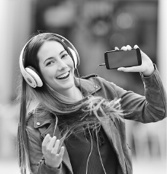 |  | 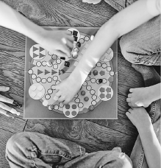
1.________________________ | 2.________________________ | 3.________________________ | 4.________________________
F. Match the summer activities from the box with their definitions. There are two extra activities.
fishing | camping | surfing | snorkelling | sailing | sunbathing

1. To ride on a wave in the sea using a special board. _____________________
2. To swim using a tube to breathe underwater. _____________________
3. To sit or lie in the sun so that your skin becomes darker. _____________________
4. To stay and sleep in an outside area, usually in a tent. _____________________
G. Complete the sentences with will and the verbs in brackets.
1. We _____________________ (go) to the beach by bus.
2. The football match is about to start. I _____________________ (call) Mum.
3. They _____________________ (not have) coffee after dinner.
4. My cousin _____________________ (stay) for the summer holidays next year.
5. She _____________________ (be) there tomorrow.
6. _____________________ (they/invent) a new electric car?

H. Build zero conditional sentences. Put the verb in the correct sense.
If you mix yellow and blue, you get green.
• you / mix / yellow and blue / you / get / green / .
1. you / heat / snow / it / melt / .
2. it / rain / PE lessons / be / in the gym / .
3. the teacher / not come / we / go / home / .
4. you / touch / fire / you / get / burned / .
I. Complete the first conditional sentences putting the verbs in brackets in the correct form.
1. If you _____________________ (not take) your coat, you _____________________ (catch) a cold.
2. I _____________________ (take) a taxi if I _____________________ (not go) by train.
3. If you _____________________ (follow) my instructions, you _____________________ (not get) lost.
4. He _____________________ (tell) John about the party if he _____________________ (see) him.
J. Circle the correct phrasal verb to complete the sentences.
1. Make sure you work out / log out after using a shared computer.
2. I can’t go to the party because I have to log in / look after my little sister.
3. You must fill in / work out the document with your personal information.
4. My coat is all wet. I need to log it in / take it off before I catch a cold.
K. Complete the sentences with will, be going to or the present continuous.
1. It’s so cold today. I think I _____________________ (drink) a cup of tea.
2. Next summer, we _____________________ (travel) to the Bahamas.
3. Don’t wait for me at dinner because I _____________________ (have) football practice tonight.
4. I see you’re having some problems with that. I _____________________ (help) you!
L. Complete the sentences with the correct indefinite pronoun from the box. There are two extra pronouns.
anywhere | anyone | anything | everything | everywhere

1. You look so sad today. Is _____________________ OK?
2. I’m really late! Can _____________________ help me, please?
3. Do you know where my belt is? I looked for it _____________________, but I can’t find it!

III – Writing
M. Choose ONE topic (1 or 2) and write a text (35-50 words) about it.
1. Write about your preferences on sports and free time activities. You can mention:
- free time activities/sports you do;
- where and when you do them and who with;
- your least favourite sport/free time activity. Justify.
2. Write about your plans for your next summer holidays. You can mention:
- where;
- who with;
- how long;
- summer activities.

Topic __________________________________________

