Progress Test
Name No.: _____ Class: _______ Date: ____/ ____/ ____
Mark: ________________ Teacher ____________________________ Enc. Educação
5B
I – Reading
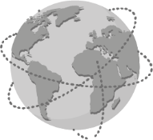
Read the text.
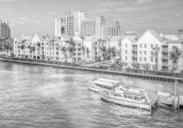
Around the World in 5 summer holiday destinations
 The Bahamas
In the Bahamas, you will get lost in the beautiful beaches. The Bahamas is the
place of Columbus’s first step when he discovered America. It has some of the
world’s most extraordinary beaches and awesome beach hotels.
Things to do: Snorkelling, going on boat tours  between Islands. | Travel tip: Do not leave your essential items on the  beach while swimming.
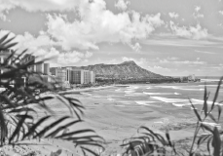
 Hawaii
It is really amazing and has got so much to offer to the tourists with some of
the most amazing islands and wonderful marine life. Hawaii is an attractive
destination for honeymooners¹, adventure lovers and families.
Things to do: Learn surfing in  Waikiki. | Travel tip: Going out to the mountains can be dangerous.  Try to be safe while taking photos!
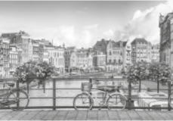
 Amsterdam
A lovely city where you can find beautiful cafés, houseboats and canals. It is a
popular destination in Europe for every traveller. You can find historical buildings
with amazing architecture.
Things to do: Cycling through the city; visiting  the Van Gogh Museum. | Travel tip: Do not walk in the cycle lanes.  Locals² will get really angry about it.

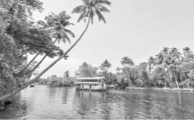
 Kerala, India
In Kerala you can find colonial landmarks³ and vibrant culture. Kerala’s beaches,
lakes, waterfalls, palaces and wildlife sanctuaries are major attractions.
Things to do: Staying in a houseboat. | Travel tip: If you enter any temple, you will have to take  off your shoes first.

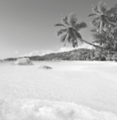
 The Seychelles
The Seychelles are a group of islands in the Indian Ocean. A clear blue sky, turquoise
water and calm beaches make this destination very popular. There are pink sand
beaches which are amazing.
Things to do: Scuba diving. | Travel tip: In order to protect the flora and fauna, don’t take  things from beaches, such as sea shells.
https://www.pahaditravelers.com (abridged and adapted, accessed in December 2020)
Vocabulary: ¹ honeymooners = casais em lua de mel; ² locals = locais; ³ landmarks = marcos/atrações


A. Where can you do these activities? Circle the correct option to label the pictures.
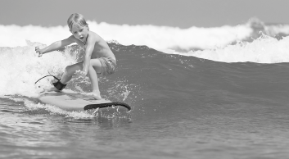 | 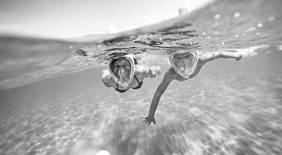
1. The Seychelles / Hawaii | 3. Amsterdam / The Bahamas
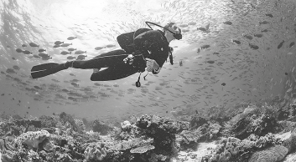 | 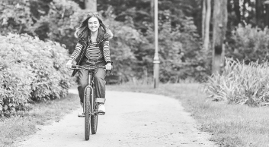
2. Amsterdam / The Seychelles | 4. Hawaii / Amsterdam
B. Circle the correct option to complete the sentences according to the texts.
1. You must be careful with your essential items when you go swimming in
the Bahamas / the Seychelles.
2. Hawaii is the perfect destination for families / teenagers.
3. Be hopeful / careful when you take photos in the mountains. It can be dangerous.
4. We can find houseboats in Amsterdam and Bahamas / Kerala and Amsterdam.
5. Before entering a houseboat / temple in India, people must take off their shoes.
6. In some beaches in the Seychelles the sand is turquoise / pink.
C. Read the questions and complete the answers, according to the texts.
1. Who discovered America? (destination no. 1)
discovered America.

2. Where can we find awesome beach hotels? (destination no. 1)
We can find awesome beach hotels in

3. What will Amsterdam locals get angry about? (destination no. 3 – travel tip)
They will get angry if people walk in the

4. What are the main attractions in Kerala? (destination no. 4)
The main attractions are the beaches, lakes

5. Why can’t people take things from the beach in the Seychelles? (destination no. 5 – travel tip)
In order to , people can't take things from the beach.

II – Language
D. Fill in the table with the sports from the box.
gymnastics | skateboarding | football | basketball | karate | running

1. Play… (ball sports) | 2. Do… (non-team sports) | 3. Go… (sports that end with -ing)
• | • | •
• | • | •
E. Complete the free time activities to label the pictures.
 | 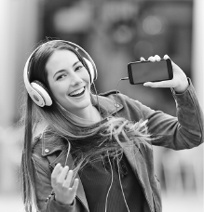 |  | 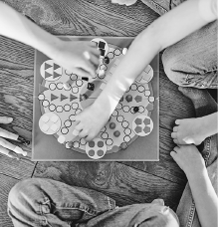
1. TV | 2. to music | 3. watching | 4. board games
F. Match the summer activities from the box with their definitions.
camping | surfing | snorkelling | sunbathing

1. To ride on a wave in the sea using a special board. _____________________
2. To swim using a tube to breath underwater. _____________________
3. To sit or lie in the sun so that your skin becomes darker. _____________________
4. To stay and sleep in an outside area, usually in a tent. _____________________
G. Complete the sentences with will and the verbs in brackets.
will play
• She _____________________ (play) basketball.
1. We _____________________ (go) to the beach by bus.
2. The football match is about to start. I _____________________ (call) Mum.
3. They _____________________ (not have) coffee after dinner.
4. My cousin _____________________ (stay) for the summer holidays next year.
5. She _____________________ (be) there tomorrow.
6. They _____________________ (invent) a new electric car.

H. Circle the correct form of the verbs to complete the zero conditional sentences.
1. If you heat snow, it melt / melts.
2. If it rains, PE lessons is / are in the gym.
3. If the teacher doesn’t come, we goes / go home.
4. If you touch fire, you gets / get burned.
I. Circle the correct option to make the first conditional sentences.
1. If you don’t take your coat, you catch / will catch a cold.
2. I will take a taxi if I don’t go / won’t go by train.
3. If you follow my instructions, you don’t get / won’t get lost.
4. He will tell John about the party if he sees / will see him.
J. Circle the correct phrasal verb to complete the sentences.
1. Make sure you work out / log out after using a shared computer.
2. I can’t go to the party because I have to look after / fill in my little sister.
3. You must fill in / work out the document with your personal information.
4. My coat is all wet. I need to log it in / take it off before I catch a cold.
K. Circle the correct verb forms to complete the sentences.
1. It’s so cold today. I think I will drink / am drinking a cup of tea.
2. Next summer, we travel / are going to travel to the Bahamas.
3. Don’t wait for me at dinner because I am having / was having football practice tonight.
4. I see you’re having some problems with that. I am helping / will help you!
L. Complete the sentences with the correct indefinite pronoun from the box.
anyone | everything | everywhere

1. You look so sad today. Is _____________________ OK?
2. I’m really late! Can _____________________ help me, please?
3. Do you know where my belt is? I looked for it _____________________, but I can’t find it!

III – Writing
M. Write a text (35-50 words) about your preferences on sports and free time activities. You can answer the questions below and
use the words from the vocabulary box.
- watching TV / listening to music / texting /
taking selfies /…
- every day / every week / on weekends / on
Tuesdays / …
- alone / my friends / my family / my brother /
…
- basketball / football / gymnastics / cycling /
running / karate /…
- sports field / school / home / stadium /
street /…
- shorts / T-shirt / racket / bat / gloves /…
- I’m not good at it / it’s boring / it’s difficult /
…
Vocabulary box
- What are your favourite free time activities?
- When do you do them?
- Who do you do them with?
- What sports do you do?
- Where do you do them?
- What equipment do you need?
- What is your least favourite sport? Why?

My favourite free time activities are

