Progress Test
Name No.: _____ Class: _______ Date: ____/ ____/ ____
Mark: ________________ Teacher ____________________________ Enc. Educação
5C

A. Read text and use the underlined words to label the pictures.

The Bahamas – the best Summer Holiday Destination
 The Bahamas
In the Bahamas, you will get lost in the beautiful beaches. The Bahamas is the
place of Columbus’s first step when he discovered America. It has some of the
world’s most extraordinary beaches and awesome beach hotels.
Things to do: Snorkelling, going on boat tours  between Islands. | Travel tip: Do not leave your essential items on the  beach while swimming.

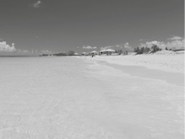 | 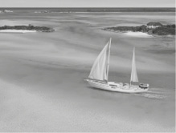 | 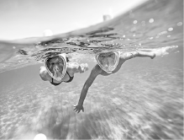 | 
1. | 2. | 3. | 4.
B. Fill in the table with the sports from the box.
gymnastics
football
basketball
karate
1. Play… (team sports) | 2. Do… (non-team sports)
• | •
• | •
E. Complete the free time activities with the missing vowels.
 |  | 
1. W__TCH__NG TV | 2. L__ST__N__NG T__ M__S__C | 3. W__TCH__NG V__D__ __S

D. Choose the correct summer activities from the box according to their definitions.



camping | surfing | snorkelling | sunbathing

1. To ride on a wave  in the sea using a special board. _____________________
2. To swim using a tube 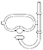 to breath underwater. _____________________
3. To sit or lie in the sun  so that your skin becomes darker. _____________________
4. To stay and sleep in an outside area, usually in a tent . _____________________

E. Complete the sentences with will and the verbs in brackets.
will play
• She _____________________ (play) basketball.
1. We _____________________ (go) to the beach by bus.
2. The football match is about to start. I _____________________ (call) Mum.
3. My cousin _____________________ (stay) for the summer holidays next year.
4. She _____________________ (be) there tomorrow.
F. Are the sentences conditionals type 0 or type 1?
Tick (✓) the correct option. TYPE 0 TYPE 1
• If you mix blue and yellow you get green.
✓

• If it rains, we will play inside.

✓
1. If you heat snow, it melts.

2. If you don’t follow my instructions, you will get lost.

3. If you touch fire, you get burned.

4. If I see John, I will tell him.


G. Circle the correct word to complete the phrasal verbs.
1. Make sure you log off / out after using a shared computer.
2. I can’t go to the party because I have to look after / in my little sister.
3. You must fill in / out the document with your personal information.
H. Match the sentences with the future forms. Draw lines.
1. It’s so cold today, I think I will drink a cup of tea. | • | • | a) present continuous
2. Next summer, we are going to travel to Bahamas. | • | • | b) be going to
3. Don’t wait for me at dinner because I am having football  practice tonight. | • | • | c) will + infinitive
I. Circle the correct indefinite pronoun to complete the sentences.
1. You look so sad today. Is someone / everything, OK?
2. I’m really late. Can everywhere / anyone help me, please?
3. Do you know where my belt is? I looked for it everywhere / everything, but I can’t find it!
J. Answer the questions about you.
1. What is your favourite sport?
My favourite sport is (football/basketball/karate...)

2. What is your favourite free time activity?
(watching TV/playing videogames...)

3. Where do you do it?
(home/school...)

4. Who do you do it with?
(alone/with friends/with family)

