Progress Test
Name No.: _____ Class: _______ Date: ____/ ____/ ____
Mark: ________________ Teacher ____________________________ Enc. Educação
Extensive Reading
Around the World in Eighty Days – The diary of Phileas Fogg
A. Match the names of the characters with their description. Write the letters a-e.
1. Phileas Fogg a) A guide who helps the main character to cross the forest, on their way to Calcutta.

2. Passepartout b) A detective who is trying to put the main character in prison.

3. Aouda c) This person makes a bet that he can travel around the world in 80 days.

4. Fix d) This person falls in love with the main character and asks him to marry her.

5. Ali e) The main character’s servant and friend.

B. Tick (✓) the means of transport used by the characters during the story.

1

2

3

4

5

C. What happened where? Match the sentences with the places.
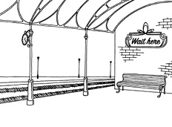  a) |  |   b) |  |   c)
 | 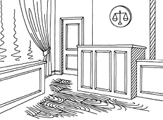  d) |  |   e)
1. Fogg and Aounda find Passepartout performing in a human pyramid.

2. Fix arrests Phileas Fogg.

3. Priests scream at Passpartout because he has his shoes on.

4. Fogg and Passepartout are sentenced to one month in prison.

5. Passepartout prepares their bags for the journey.

D. Order the countries Phileas Fogg visited, according to the text.
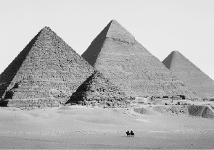  Egypt |   The USA |   1  The UK
  India |   Japan |   China

E. Who said what? Circle the correct option.
1. “I believe he can escape because the world is big enough!”
Phileas Fogg / Passepartout / Stuart
2. “There is a man with a moustache who keeps asking me questions about our journey.”
Ali / Passepartout / Aouda
3. “Look! There’s an elephant! Why don’t we negotiate with its owner and travel by elephant?”
Passepartout / Phileas Fogg / Policeman
4. “Everyone knows her because she is very beautiful and
she was forced to marry the old prince of this village.”
Phileas Fogg / Ali / Fix
5. “Thank you so much for saving my life.”
Aouda / Phileas Fogg / Ali
6. “Phileas Fogg, you’re under arrest.”
Priests / Policeman / Judge
7. “He entered the temple with shoes on!”
Priests / Policeman / Judge
8. “I arrest you in the name of the Queen!”
Fix / Phileas Fogg / Aouda
9. You are a wonderful man, so… would you like to marry me?”
Passepartout / Aouda / Stuart
10. “Today is Sunday, so find a priest and ask him if he can marry us tomorrow.”
Phileas Fogg / Passepartout / Aouda

