Speaking Test
Name No.: _____ Class: _______ Date: ____/ ____/ ____
Mark: ________________ Teacher ____________________________ Enc. Educação
2
Spoken Production
Describing a school in the past
A. Bring a photo of a school you went to in the past (for example, primary school).
B. Present the school, using the past simple. Follow the topics:
Name of the school
Location
What it was like
School facilities/rooms
Your favourite part of the school – why
Your opinion about the school

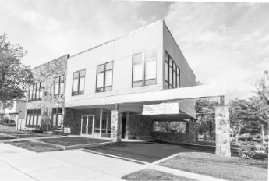
Hello! When I was 6 years old, I went to Staten Island Academy, in
New York. This is it. As you can see, the school was old, but very big.
There were lots of classrooms, a staffroom,
a library and a big sports field.
My favourite part of the school
was the canteen because I loved
having lunch with my friends.
I really liked Staten Island Academy
because I had lots of friends and
I was very happy there.
Spoken Interaction
Asking and answering about school
A. Use the prompts to make questions for your partner. Then take turns. Use the present simple and start as the example.
What is the name of your school?
What / name / school
The name of my school is
Staten Island Academy.
What / school / like
What / favourite school subject
What is your school like?
What / least favourite school subject
What / favourite school room/facility / Why
It is big but not very modern.
There are lots of classrooms, a big
library and a canteen.
What / after-school clubs
What / favourite place / school
Where / have lunch
...
What / favourite school event

