Speaking Test
Name No.: _____ Class: _______ Date: ____/ ____/ ____
Mark: ________________ Teacher ____________________________ Enc. Educação
3
Spoken Production
Talking about your favourite sport
A. Bring an object that represents a sport you do/like.
B. Present it to the class, according to the following topics:
Describe the object
Favourite sport
Where you do the sport
Who with
When you do the sport
Material / equipment you need
Why you like it
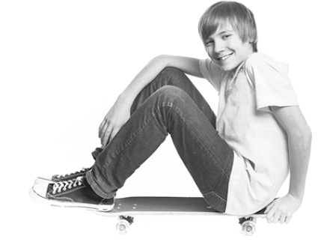

Hello! This is a tennis ball. It is small and green.
It represents my favourite sport: tennis.
I started playing tennis when I was 5 years old.
I play in a tennis club with my brother. We have
tennis practice on Mondays and Wednesdays.
To play tennis I need trainers, shorts,
a T-shirt and a racket. Sometimes
I wear a cap. I love playing tennis
because I love the feeling of
winning a match.
Spoken Interaction
Asking and answering about free time/summer activities
A. Use the prompts to make questions for your partner. Then take turns. Start as the example.
I like watching TV, listening to
music and playing the piano.
What do you do in your free time?
What / do / free time
What / favourite / free time activity
What is your favourite free time activity?
Why
My favourite free time activity is
listening to music.
Where / do / it
Why?
Who / do / it / with
I like it because music it makes me feel good.
When / do / it
...
What / favourite / summer activity
Why

