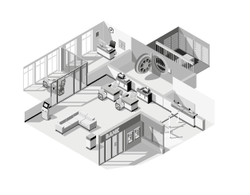
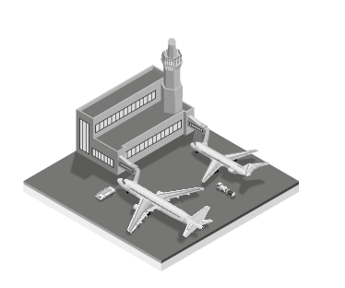
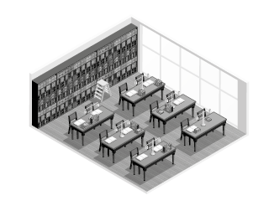
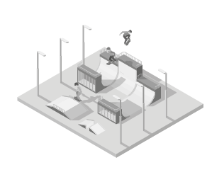
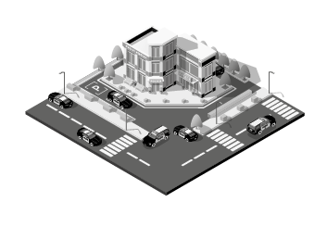
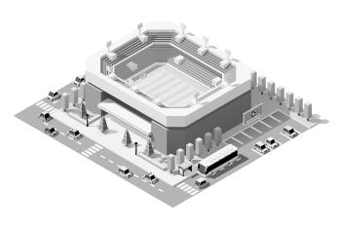
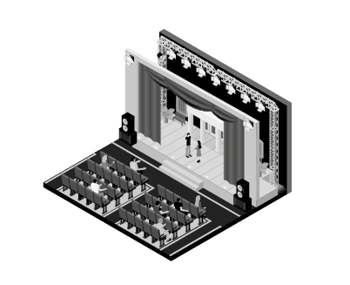
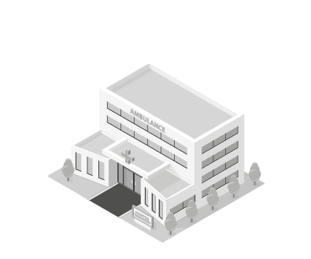
1
2
3
4
5
6
7
8

Unit 4 – subunit 4.1
Minitest
Name No.: _____ Class: _______ Date: ____/ ____/ ____
Mark: ________________ Teacher ____________________________ Enc. Educação
9
A. Look at the pictures and write the names of the city places.
8 x 4% = 32%

1._________________  2._________________ | 3._________________  4._________________ | 5._________________  6._________________ | 7._________________  8._________________
B. Match the two parts of the expressions. Write the letters a-f.
6 x 4% = 24%
1. go for | 5. walk along | a) attraction | d) the dog
2. visit an | 4. visit a | b) shopping | e) a walk
3. walk | 6. go | c) museum | f) the streets
C. Write sentences in the past continuous.
Martha was visiting an exhibition.
4 x 5% = 20%
• Martha / visit / an exhibition / .
1. you / walk / down the avenue / .
2. Jessie / not watch / the dolphins / at the aquarium / .
3. the plane / fly / to Liverpool / ?
4. Will and Jack / climb / a skyscraper / .
D. Past simple or past continuous? Fill in the gaps with the correct verb forms.
6 x 4% = 24%
1. While I _________________ (drink) delicious mango juice, my sister was trying the pineapple one.
2. When Louise _________________ (arrive) at the park, Zoe was running with her dog.
3. Last week they went to the zoo and _________________ (watch) the tigers.
4. Our grandparents _________________ (chat) online while we were playing video games.
5. Sean _________________ (read) his favourite book when the phone _________________ (ring).

