Unit 4 – subunits 4.2 and 4.3
Minitest
Name No.: _____ Class: _______ Date: ____/ ____/ ____
Mark: ________________ Teacher ____________________________ Enc. Educação
10
A. Where did they go shopping? Read the sentences and fill in the gaps with the correct shops.
4 x 5% = 20%
Nina bought some vegetables at the
¹____________________, but she forgot
to buy bread at the ²__________________.
Lisa loves flowers, so Neil went to the
³______________ and bought her beautiful roses.
Then he saw the newspaper’s headlines and
decided to buy one at the ⁴_____________.
B. Label the city features.
5 x 4% = 20%
 | 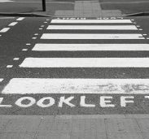 | 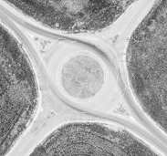 | 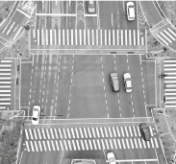 | 
1._________________ | 2._________________ | 3._________________ | 4._________________ | 5._________________

C. Circle the correct modal verbs.
4 x 5% = 20%
1. Sue might / can speak German very well. She’s brilliant at it.
2. Walt may / must stop talking in the library. Mrs Connor is getting tired of his noise.
3. You’re very pale. You should / can go to the hospital.
4. People might / shouldn’t be rude.
D. Write the imperative of the verbs from the box under each sign to complete the sentences.
be
not swim
not run
share
4 x 5% = 20%
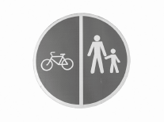 |  |  | 
1._________________  the cycle lane. | 2._________________  in the lake. | 3._________________  quiet in the library! | 4._________________  here!
E. Look at the pictures and write the prepositions of movement into, across, through or over.
4 x 5% = 20%
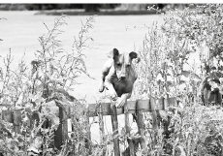 |  |  | 
1. Rudolph is jumping  __________ the fence. | 2. She is walking  __________ the street. | 3. The hamster is going  __________ the cage. | 4. Vince is running  __________ the tunnel.

