Unit 5 – subunit 5.2
Minitest
Name No.: _____ Class: _______ Date: ____/ ____/ ____
Mark: ________________ Teacher ____________________________ Enc. Educação
12
A. Complete the sentences with the summer activities in the pictures.
8 x 5% = 40%
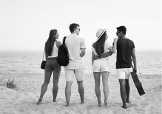  1 | 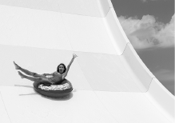  2 |   3 | 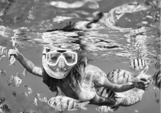  4
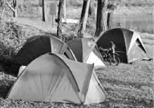  5 | 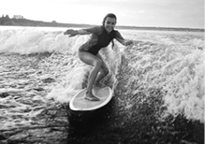  6 | 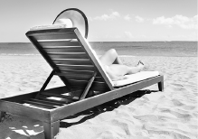  7 |   8
1. Sarah loves ______________ with her friends because she enjoys watching the sea.
2. My classmates’ favourite summer activity is ______________.
3. ______________ is refreshing. My favourite flavours are strawberry and vanilla.
4. “What’s your favourite activity?” “______________. I love exploring the sea.”
5. I promise we’ll go ______________ this July. I’m buying a new tent this weekend.
6. I’m going to Ericeira to watch Vasco Ribeiro ______________. He “flies” on his board!
7. ______________ is relaxing and warm but we mustn’t forget to protect our skin!
8. ______________ with my family is great! My aunt Mimi usually prepares her special fruit salad.
B. Complete the sentences with the correct future forms: will + infinitive or be going to + infinitive.
4 x 5% = 20%
1. I promise we ______________ (go) to a giant water park.
2. Jennifer has her holiday planned. She ______________ (surf) in Hawaii next year.
3. Rose and Jack ______________ (have) a picnic with their family this weekend. It’s decided.
4. I hope you ______________ (not eat) another ice cream today. It’s too cold.
C. Write sentences about the future using the present continuous of the verbs.
4 x 5% = 20%
1. Luana / hang out / with her friends later
2. we / go / to the beach this morning
3. they / have / so much fun at tonight’s party
4. I / sail / my uncle’s boat today

D. Circle the correct indefinite pronouns.
5 x 4% = 20%
1. I can’t find my sunglasses somewhere / anywhere.
2. Did you invite everything / everyone to the beach party?
3. Are you OK? Do you need anywhere / anything?
4. “Where are you going tonight?” “I’m going nowhere / anywhere. I’ll stay at home.”
5. Ashley is setting everything / anyone for the picnic she’s having.

