Unit 1 – subunit 1.2
Minitest
Name No.: _____ Class: _______ Date: ____/ ____/ ____
Mark: ________________ Teacher ____________________________ Enc. Educação
2
A. Complete the table with the family members (male or female).
4 x 5% = 20%
Male | Female |  | Male | Female
1. father |  |  | 3. husband
2. | daughter |  | 4. | uncle
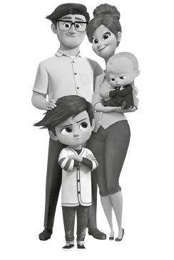

B. Look at the picture and circle the correct words to describe the Templetons.
12 x 2% = 24%
Ted, the father, is ¹ tall / short. His hair is ² long / short and
³ curly / straight. He has got ⁴ glasses / a beard and his eyes are
⁵ tall / big. Janice, the mother, is tall and she is ⁶ fat / slim.
She has got ⁷ short / long hair, her face is ⁸ oval / round and her skin is
⁹ fair / dark. Tim, the older son, isn’t ¹⁰ tall / short. He is ¹¹ fat / thin
and he has got ¹² big / small round eyes.
C. Fill in the blanks with the present simple of the verb have got.
6 x 6% = 36%
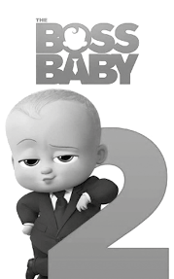
The Templetons are a different family. All of them ¹_____________ something
in common: Baby Corp, a family business and a big secret, a baby drink
that turns adults into babies again. Can you imagine?
Ted, or Boss Baby, ²_____________ short blonde hair and big eyes. He usually
wears a suit and tie because he loves it and he ³_____________ (not) trainers
or casual clothes. He is Tina and Tabitha’s uncle and they ⁴_____________
a very special relationship. ⁵_____________ (they) secrets? Yes,
they ⁶_____________. And the girls’ parents don’t like it at all.
D. Replace the underlined possessive pronouns with the correct ones.
4 x 5% = 20%
1. Boss Baby has got a company, but it isn’t only mine; it is also his brother’s company.

2. Tina and Tabitha have got a secret. I have got secrets, too, but yours is extraordinary.

3. Carol’s daughters are very sweet. They could only be ours because she’s also kind.

4. I have got the Boss Baby films. They were a gift from my father. They are theirs now.

