Unit 2 – subunit 2.1
Minitest
Name No.: _____ Class: _______ Date: ____/ ____/ ____
Mark: ________________ Teacher ____________________________ Enc. Educação
4
A. Look at the pictures and label the household chores.
5 x 4% = 20%
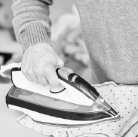 |  | 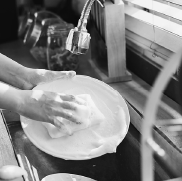 | 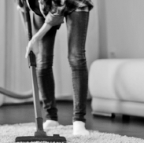 | 
1.___________________ | 2.___________________ | 3.___________________ | 4.___________________ | 5.___________________
B. Write the present continuous of the verbs in brackets to complete the dialogues.
14 x 4% = 56%
Maggie: Hey, Jo. What ¹_________ (you/do)?
Jo: Hi, Maggie. I ²____________________ (tidy)
my bedroom and ³___________ (vacuum)
the floor. What about you?
Maggie: Well, I ⁴__________ (listen) to music
while I ⁵____________ (clean) the bathroom.
Today is household day here, too. J
Jo: ⁶__________________ (your brothers/help)
you?
Maggie: No, they ⁷________________. Can you
believe it? They ⁸___________________ (play)
video games downstairs while my Mum
⁹__________________ (do) the washing up. L
Brian: Hi, Logan. Are you busy?
Logan: Hey. Yes, I am. My parents and
I ¹⁰______________________ (do) the chores
today. It’s Saturday, remember?
My Dad ¹¹_______________ (wash) the car,
my Mum ¹²_______________ (cut) the grass
and my sister ¹³_________________ (not do)
anything. She says she’s tired…
Brian: Oh, well, I ¹⁴___________________ (try)
a new PS game… Do you want to play
with me?
Logan: I’m sorry, mate. Not today.
C. Write questions and answers in the present continuous. Use the words given.
Is Mary doing the
laundry? No, she isn't.
She is loading the
dishwasher.
3 x 4% = 12%
• Mary / do / the  laundry / load  the dishwasher  _____________________  _____________________  _____________________  _____________________ | 1. Vince / sweep /  the floor /  mop the floor  _____________________  _____________________  _____________________  _____________________ | 2. Nina and Lisa /  set / the table  _____________________  _____________________  _____________________  _____________________ | 3. George / make /  his bed  _____________________  _____________________  _____________________  _____________________

D. Present simple or present continuous? Circle the correct verb forms.
6 x 2% = 12%
1. Molly and I study / are studying now. 4. We hardly ever are cooking / cook lunch.
2. My three dogs are sleeping / sleep at the moment. 5. I run / am running in the park right now.
3. Ron often folds / is folding his clothes. 6. You never make / are making your bed.

