Unit 2 – subunit 2.2
Minitest
Name No.: _____ Class: _______ Date: ____/ ____/ ____
Mark: ________________ Teacher ____________________________ Enc. Educação
5
A. Unscramble the letters and write the types of houses.
4 x 4% = 16%
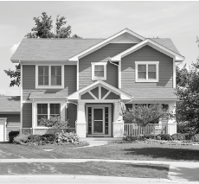 | 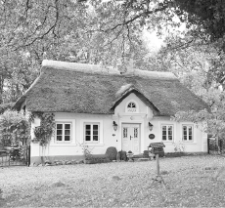 | 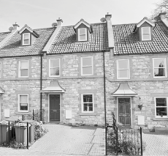 | 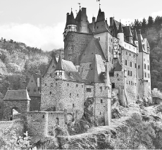
EHDATCDE house  1.______________________ | GOTCTEA  2.______________________ | DERTRCEA house  3.______________________ | EASCLT  4.______________________
B. Read the clues and write the correct rooms/parts of the house. Use the words from the box.
6 x 4% = 24%
bedroom | study | window | garden | attic | kitchen

1. It is made of glass and I can see my garden through it. _________________________
2. There are old boxes and “treasures” in this room. _________________________
3. I sleep and listen to music in this room. _________________________
4. We cook dinner here. _________________________
5. There are trees and flowers in this place. _________________________
6. I do my homework here. _________________________
C. Write the plural of the nouns.
10 x 4% = 40%
singular | plural |  | singular | plural
1. garden |  |  | 6. policeman
2. balcony |  |  | 7. house
3. bookshelf |  |  | 8. chimney
4. tomato |  |  | 9. child
5. person |  |  | 10. door

D. Circle the correct object pronoun.
5 x 4% = 20%
1. That flat isn’t mine. It’s John’s. It belongs to her / him.
2. Can you give me / you that vase of flowers, please? I need to water me / them.
3. “Whose palace is that?” “I don’t know, but I think it is the Queen’s. It belongs to us / her.”
4. We want to buy a cottage in the countryside. Can you tell them / us the best place to buy one?

