Unit 2 – subunit 2.3
Minitest
Name No.: _____ Class: _______ Date: ____/ ____/ ____
Mark: ________________ Teacher ____________________________ Enc. Educação
6
A. Match the words from the box with the pictures. Write the letters a-j.
10 x 4% = 40%
a) cooker | b) TV set | c) cupboard | d) picture | e) oven
f) sink | g) sofa | h) fridge | i) rug | j) armchair

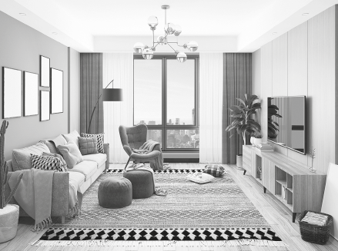  1  2  3  4  5 | 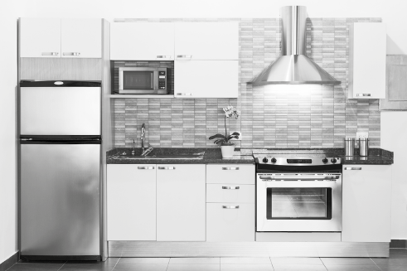  6  7  8  9  10
B. Look at the picture and complete the text with the prepositions of place on, above, under,
in front of, between or next to.
6 x 6% = 36%
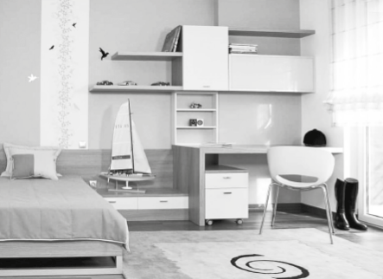
In Simon’s bedroom there are boots ¹_____________ the
desk and some bookshelves ²_____________________ the
desk and the bedside table. There's a small boat
³__________________ the bed and the desk. There is a rug
⁴____________________ the chair. There are some pillows
⁵_____________________ the bed and there is a chair
⁶_____________________ the desk.

C. Complete the words in the sentences with the prefixes and suffixes below.
6 x 4% = 24%
un- | im- | in- | -ful | -less | -ly

1. Jenny isn’t very well today. She feels __________ happy because her work is _________ complete.
2. Violet and Jim don’t believe in ________ possible things. They are going to buy a wonder _________ house, their dream house.
3. Roman is friend __________ and kind to everyone.
4. There are many home __________ people in the streets.

