Unit 3 – subunits 3.2 and 3.3
Minitest
Name No.: _____ Class: _______ Date: ____/ ____/ ____
Mark: ________________ Teacher ____________________________ Enc. Educação
8
A. Label the pictures with the school facilities/rooms.
5 x 4% = 20%
 | 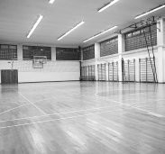 | 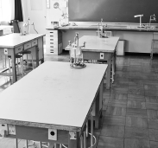 |  | 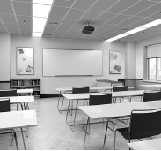
1._________________ | 2._________________ | 3._________________ | 4._________________ | 5._________________
B. Read the clues and write the school events from the box in the blanks.
4 x 5% = 20%
Sports Day | Book Fair | Singing Contest | Halloween Party

1. I’m interested in reading novels and love stories, so I should go to the school ____________________ and buy some.
2. The 31st October is almost here. Our classmates are organising a ____________________. It’s going to be “spooktacular”!
3. Football, basketball, gymnastics and so many more… let’s keep fit and healthy on our ____________.
4. You should participate in the ____________________. You’ve got such a wonderful voice!
C. Fill in the gaps with the past simple of the regular verbs in brackets.
12 x 3% = 36%
Last week I ¹_______________ (work) with Joanna on a science project. We ²_______________ (need) to
create a way of saving abandoned animals, so we ³_______________ (search) for information and
⁴_______________ (decide) to contact a dog shelter. We ⁵_______________ (not understand) much
about it and the president ⁶_______________ (not answer) our phone calls; therefore, we
⁷______________ (contact) our teacher and ⁸______________ (ask) her for help. She was great as always
and we ⁹______________ (rescue) some dogs. Everybody ¹⁰_____________ (like) our project “Caring dogs”.
¹¹_________________ (we/enjoy) ourselves helping those abandoned dogs? Yes, we ¹²_______________.
D. Write the past simple of the irregular verbs in the box to complete the sentences.
6 x 4% = 24%
1. Last year, Ted ____________________ on a school trip with his schoolmates.
take
go
meet
not know
learn
say
2. The geography teacher ____________________ them to Paris.
3. The students ____________________ a lot about the city.
4. They ____________________ new friends there.
5. They ____________________ why, but they loved that city very much.
6. They ____________________: it's a magical place!

