Countries and nationalities
Review worksheet
1
Name No.: ______ Class: ________ Date: _____/ _____/ _____
A. Look at the pictures and write the country or the nationality.
(Observa as imagens e escreve o país ou a nacionalidade.)
 |  |  | 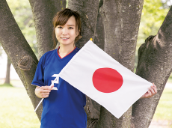
The USA | England | China | Japanese
American | 1. | 2. | 3.
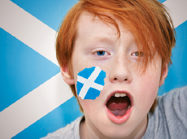 | 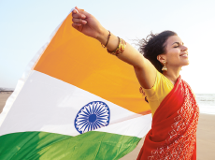 |  | 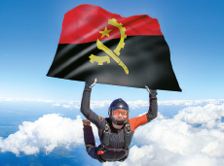
Scottish | India | Greece | Angolan
4. | 5. | 6. | 7.
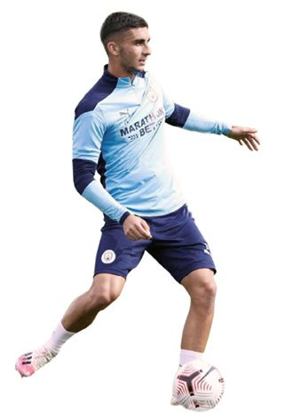

B. Complete the crossword puzzle with the correct nationalities.
(Completa as palavras cruzadas com as nacionalidades corretas.)
Ferrán
Torres
Charlize
Theron
 |  |  |  |  |  |  |  |  |  |  |  |  | 
 |  |  |  | 
 |  |  |  |  |  | 
 |  |  |  |  |  |  |  |  |  |  |  |  |  |  | 
 |  |  | 
 |  |  |  |  |  |  |  |  |  |  | 

ACROSS | DOWN
1. Luca Pellegrini is from Rome. He’s an _______________ football player. | 5. Sara Sampaio is from Portugal.  She’s _______________.
2. Charlize Theron is a _______________ actress. She was born in South Africa. | 6. Taylor Swift is from the USA, so she’s _______________.
3. Ferrán Torres is a _______________ football player. He’s from Spain. | 7. Vitor Kley is a _______________ singer. He’s from Brazil.
4. David Guetta is _______________. He was born in France. | 8. Shawn Mendes was born in Canada.  He’s _______________.

