Jobs and occupations
Review worksheet
3
Name No.: ______ Class: ________ Date: _____/ _____/ _____
A. Look at the word cloud and find five jobs.
(Observa a nuvem de palavras e descobre cinco profissões.)
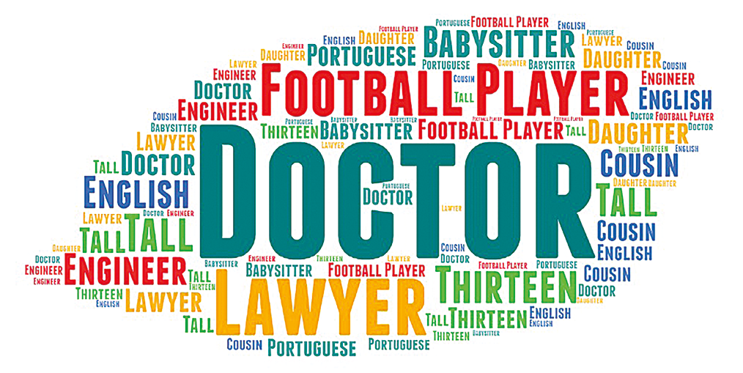
B. Label the pictures with the correct jobs and occupations.
(Legenda as imagens com as profissões e ocupações corretas.)
n
c
 |   f |   p |   m |   a
1.  t | 2. | 3. | 4. | 5.
 |  |   s |   v |   s
6. | 7. | 8. | 9. | 10.

