Body parts, physical features
and personality
Review worksheet
4
Name No.: ______ Class: ________ Date: _____/ _____/ _____

A. Label the parts of the body.
(Legenda as partes do corpo.)

1. _______________________ 6. _______________________
2. _______________________ 7. _______________________
3. _______________________ 8. _______________________
4. _______________________ 9. _______________________
5. _______________________ 10. _______________________

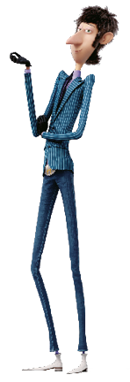

B. Match the descriptions with the pictures. Write 1-4.
(Associa as descrições às imagens. Escreve 1-4.)
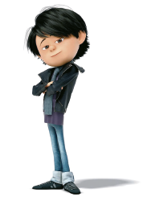 | 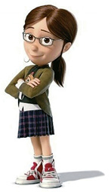 | 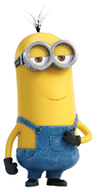
1. He/She is tall and thin. His/Her hair is short and he/she has got a big nose.
2. He/She is short and thin. His/Her hair is long, his/her nose is small and he/she wears glasses.
3. He/She is short and fat. He/She has got very short hair and wears glasses.
4. He/She is short and slim. He/She has got straight black hair and a round face.
C. Read the sentences and complete them with the words from the box.
(Lê as frases e completa-as com as palavras da caixa.)
shy
impatient
sociable
rude
1. Stuart loves talking to everyone and meeting new people. He’s very _______________.
2. Belle doesn’t like talking in public because she’s _______________.
3. Wild Knuckles isn’t nice. He treats people badly. He’s very _______________.
4. Marlena hates waiting for her turn in the canteen. She’s so _______________.

