Clothes, footwear and accessories
Review worksheet
5
Name No.: ______ Class: ________ Date: _____/ _____/ _____
A. Unscramble the letters and label the clothes and footwear.
(Ordena as letras e legenda as peças de vestuário e calçado.)
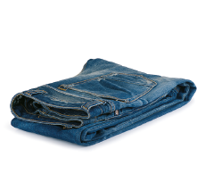 | 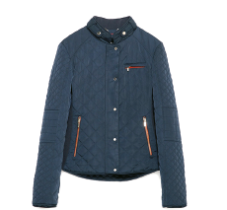 | 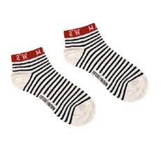 | 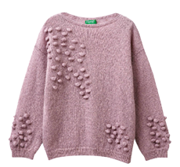
A S J N E | A J C T K E | C S O K S | E S A E W R T
1. | 2. | 3. | 4.
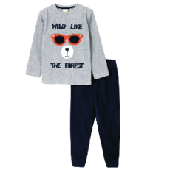 | 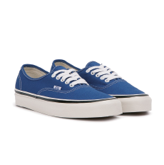 | 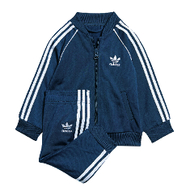 | 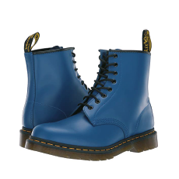
Y P S J M A A | N R A T I E S R | T K R T A C I S U | S O B T O
5. | 6. | 7. | 8.
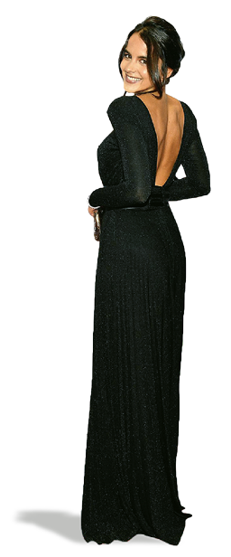
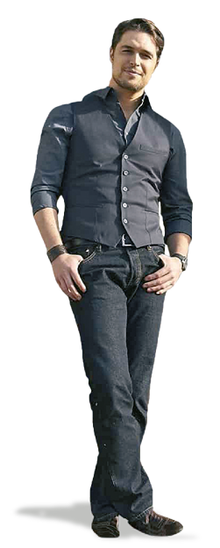
B. Look at the pictures and fill in the gaps with the words from the box. There are two extra options.
(Observa as imagens e preenche os espaços com as palavras da caixa. Há duas opções a mais.)
shoes |  | shirt |  | dress |  | T-shirt
 | jeans |  | watch |  | skirt

Diogo
Morgado
Sara
Matos
In this picture, Sara Matos is wearing a black ¹__________________.
We can’t see her ²__________________ because her outfit is too long and it touches the floor.
Diogo Morgado is wearing a pair of black ³__________________ and a dark casual ⁴__________________.
He’s also wearing a ⁵__________________ on his left wrist because he likes being on time.

