Food and drinks
Review worksheet
6
Name No.: ______ Class: ________ Date: _____/ _____/ _____
A. Write the names of the food and drinks you see in the picture.
(Escreve os nomes dos alimentos e bebidas que vês na imagem.)
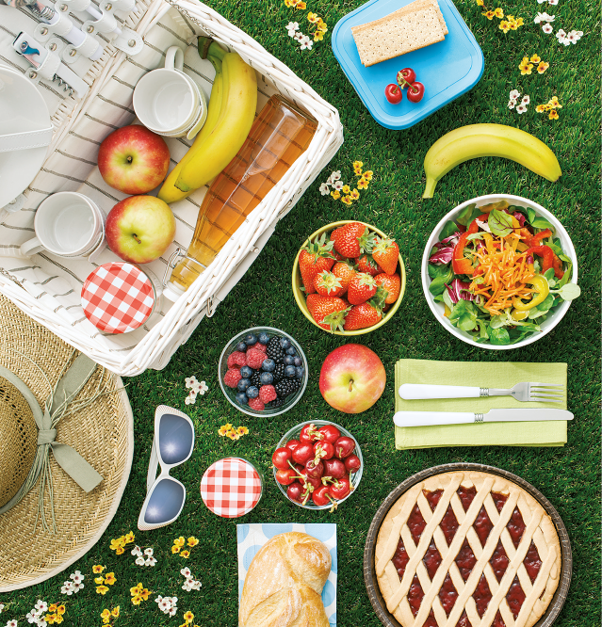
1. | 2. | 3. | 4.
5. | 6. | 7. | 8.
B. Complete the dialogue at a restaurant with the names of the food and drinks.
The pictures will help you.
(Completa o diálogo num restaurante com o nome da comida e bebida. As imagens irão ajudar-te.)
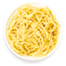
Waiter: Good morning. May I help you?
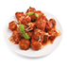
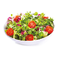
Jenny: Good morning. Yes, please. I’d like to have lunch: ¹_____________
and ²_____________ . Can you bring some ³_____________ , too, please?
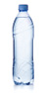
Waiter: Of course, miss. Anything to drink?
Jenny: Yes, please. I’d like a bottle of ⁴_____________ .
[After lunch…]
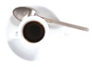
Waiter: Anything else, miss?
Jenny: Could you bring me a cup of ⁵_____________ , please?
Waiter: Right away.

