Daily routine
Review worksheet
7
Name No.: ______ Class: ________ Date: _____/ _____/ _____
A. Label the daily routine activities with the expressions from the box.
(Legenda as atividades da rotina diária com as expressões da caixa.)
have lunch | catch the bus |  |  | wake up |  | watch TV |  |  | have a shower
brush her teeth |  | get dressed |  |  | do her homework |  |  | go to bed
have breakfast |  |  | have football practice |  |  |  | play video games

 | 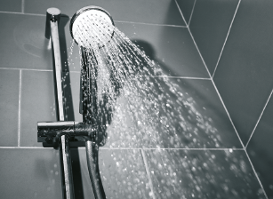 | 
1. | 2. | 3.
 |  | 
4. | 5. | 6.
 |  | 
7. | 8. | 9.
 | 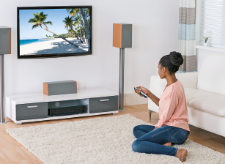 | 
10. | 11. | 12.

